Website Content – Ink Pixel Studio

Home & About Page
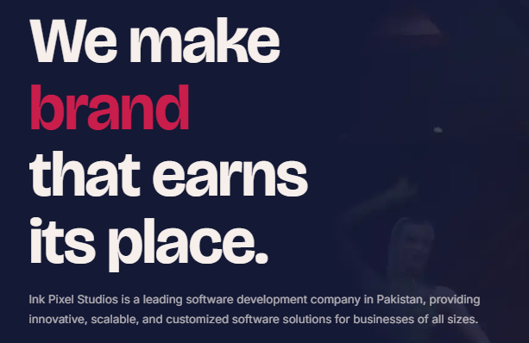

Build Smarter.
Innovate Faster.
Grow Without Limits.
Ink Pixel Studio is a place where you get to convert your visions into digital products that are successful and strong for businesses today and tomorrow.
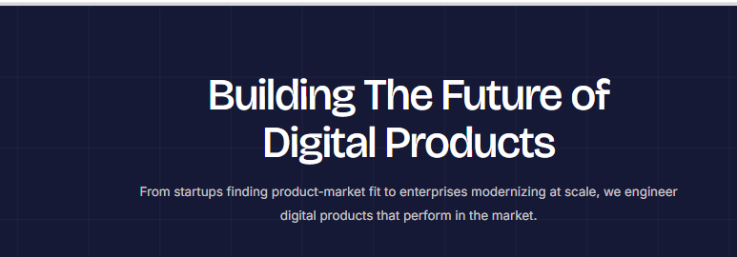

Technology Solutions Designed Around Your Business
From developing mobile apps, creating custom software solutions, advancing artificial intelligence, building cloud-based systems, designing blockchain-based architectures, or driving user experience, every solution we create brings our expertise in strategy, technology, and creativity to bear, addressing real business problems, enhancing user experiences, and enabling faster sustainable growth.
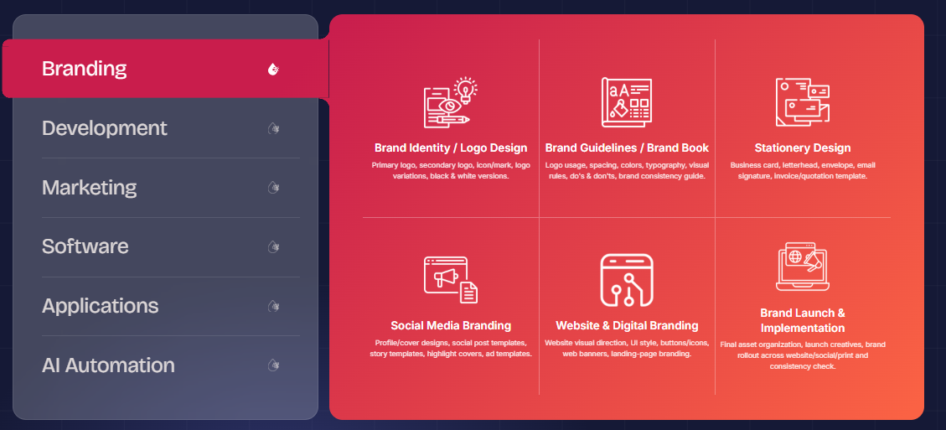

Branding
- Brand Identity / Logo Design
Ink Pixel Studio creates a memorable impression with your brand identity design and creative logo design services.
- Brand Guidelines / Brand Book
Create a visual identity by providing detailed brand guidelines for logo usage, color schemes, typography and brand elements.
- Stationery Design
Create a good first impression with branded business stationery, business cards, letterheads, envelopes, and more.
- Social Media Branding
Develop a consistent and recognizable online brand identity by using consistent templates, profile pictograms, and graphics on social media platforms.
- Website & Digital Branding
Develop a unified digital identity through website branding, with visual elements, typography, colors and digital assets that are associated with your identity.
- Brand Launch & Implementation
Whether you need help with establishing your visual presence on multiple platforms or creating and editing the assets you'll need for your marketing campaign, we have you covered.
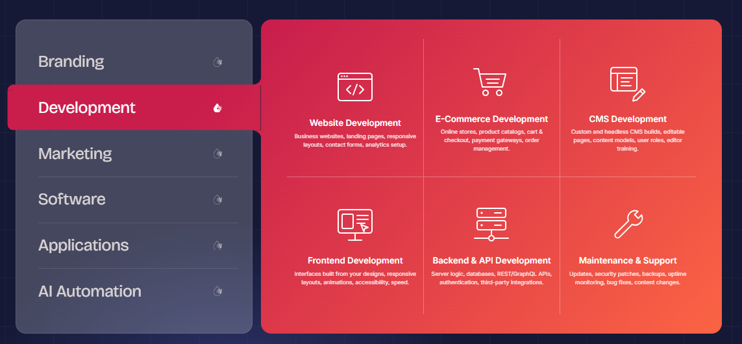

Development
- Website Development
We develop responsive business websites that are engaging and informative, convey your brand message and provide seamless web browsing experience across devices.
- E-Commerce Development
We provide eCommerce website development solutions that enable businesses to create an online store that is easy to navigate, showcases products, and offers a smooth shopping experience.
- Content Management System Development
With our CMS development services, you can easily manage, update and organize the content on your website without having to be an expert in technical matters.
- Frontend Development
We build engaging, responsive frontend interfaces using modern web technologies to ensure your website looks great and works smoothly across devices.
- Backend & API Development
Our backend development and API integration services power your website behind the scenes, managing databases, business logic, user authentication, and communication between applications.
- Maintenance & Support
Our website maintenance and support services at Ink Pixel Studio ensure your website remains secure, reliable, and functioning smoothly, keeping your business online.
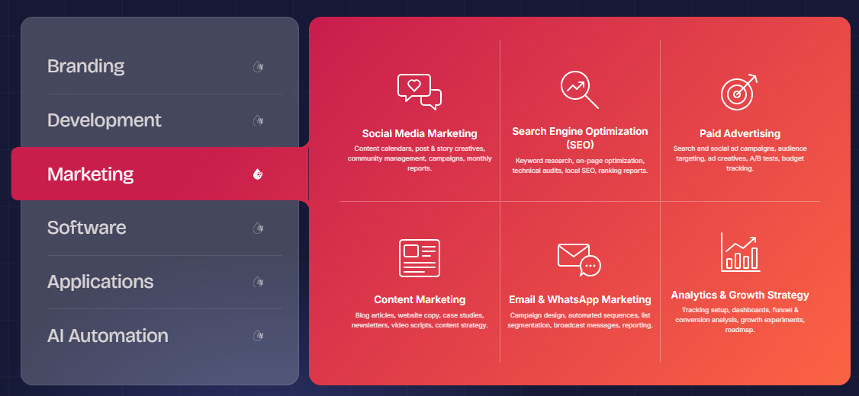

Marketing
- Search Engine Optimization (SEO)
Get your website optimized for search engines to boost its visibility, covering keyword research, on page optimization, technical optimization and content optimization.
- Paid Advertising
Connect with target audiences via relevant paid advertising like Google Ads and social media ads based on business goals, reach, frequency, and targets.
- Content Marketing
Engage customers with the right content marketing services, such as blogs, website content, social media and useful brand resources.
- Email & WhatsApp Marketing
Improve customer relations by engaging them with tailored email marketing and WhatsApp marketing messages, which convey updates and offers and cultivate leads.
- Social Media Marketing
Ink Pixel Studio is dedicated to helping businesses create meaningful connections online through innovative social media marketing solutions designed for businesses and their audience.
- Analytics & Growth Strategy
Ink Pixel Studio's data-driven analytics and growth strategy services assist businesses in making intelligent decisions and fostering sustainable growth.

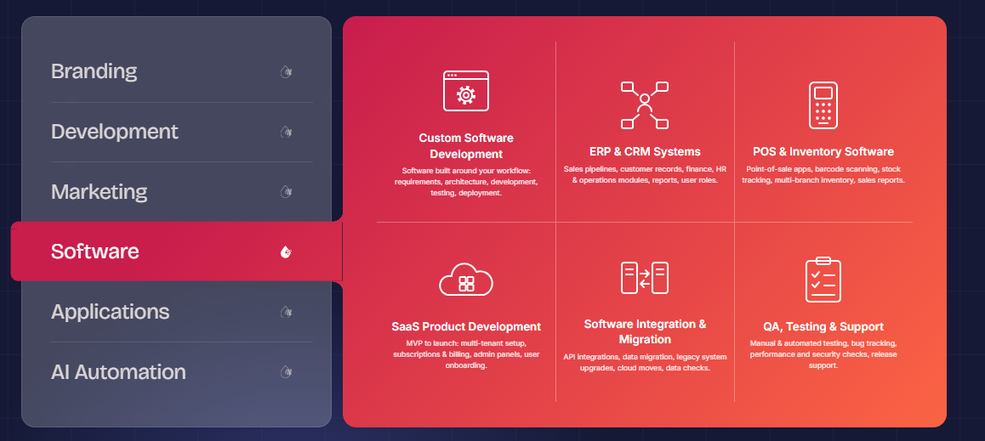

Software
- Custom Software Development
Ink Pixel Studio specialize in delivering bespoke custom software solutions that enable businesses to streamline their operations, address unique challenges, and boost productivity.
- ERP & CRM Systems
We create bespoke ERP and CRM solutions to streamline processes between departments, centralize business operations and manage customer relationships.
- POS & Inventory Software
The POS and inventory management software streamlines business operations, enabling seamless transactions, inventory tracking, and sales management through a digital system.
- SaaS Product Development
We develop scalable Software as a Service (SaaS) application that enable companies to offer digital products and services on cloud-based, easily accessible platforms.
- Software Integration & Migration
Our software integration and migration services ensure seamless data transfer, link existing systems and support businesses to new platforms and platforms with minimal disruption.
- QA Testing & Support
Whether it's functional testing and performance testing, compatibility checks, or tracking bugs and providing continuous support, we help minimize technical problems and enhance the user experience.

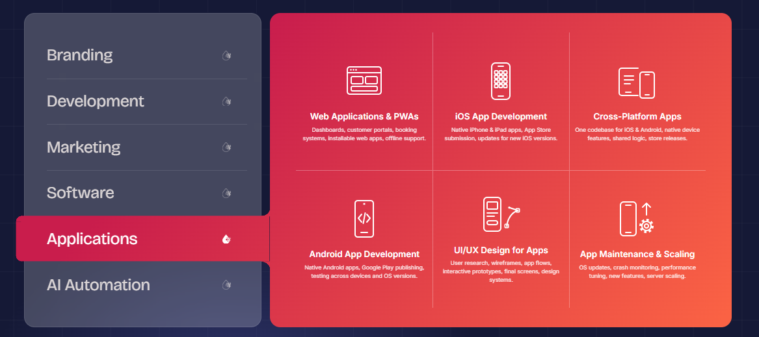

Applications
- Web Applications & PWAs Services
Ink Pixel Studio creates scalable web app development and Progressive Web Apps (PWAs) to assist businesses in providing a seamless digital experience across devices.
- iOS App Development
We create robust and efficient iOS apps optimized for iPhone and iPad, featuring intuitive design, dependable performance, and integration with the Apple ecosystem.
- Cross-Platform Apps
We're experts in app development across multiple platforms, offering you apps that work on both iOS and Android with a shared codebase as much as possible.
- Android App Development
We create custom Android applications that are optimized for performance, usability and user-friendliness on Android devices that have the required compatibility.
- UI/UX Design for Apps
Our UI/UX design for mobile application is focused on intuitive navigation, clear layouts and user journeys to make the applications easier to use.
- App Maintenance & Scaling
Our app scaling solutions can handle growing users, data growth, and changing business requirements without impacting the user experience as your business expands.
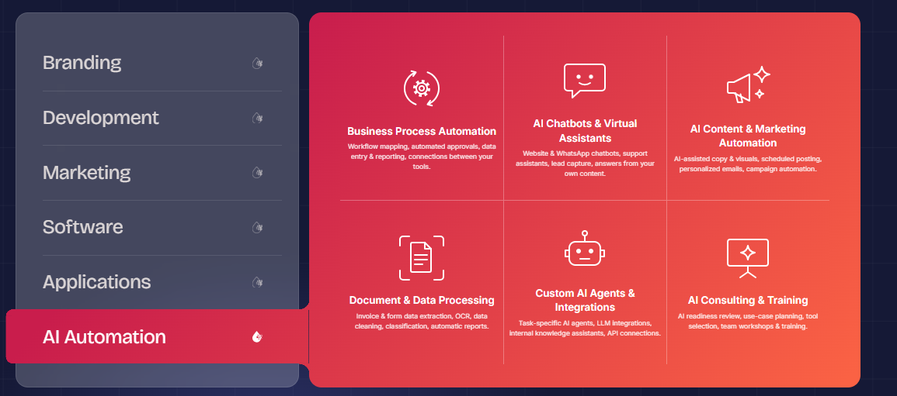

AI Automation
- Business Process Automation
We at Ink Pixel Studio aim to make business life easier with custom Business Process Automation (BPA) services that eliminate manual processes, enhance accuracy and boost productivity.
- AI Chatbots & Virtual Assistants
Use intelligent AI chatbots and virtual assistants to automate customer support, answer common questions, and give prompt assistance.
- AI Content and Marketing Automation
Find smart ways to create content, build campaigns and automate repetitive marketing with AI-based content and marketing automation tools.
- Document & Data Processing
Minimize manual workload and process document handling, data extraction, classification and information processing with AI driven data solutions.
- Custom AI Agent & Integration
Create intelligent custom AI agents which can complete specific tasks and communicate with other business tools and software.
- AI Consulting & Training
We offer AI Strategy Consulting, Automation Planning, Tool Selection, Employee Training, and guidance for integrating AI into existing operations.
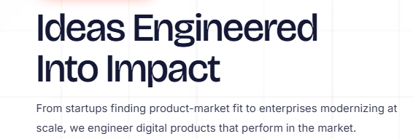

Stay Ahead. Stay Informed. Be Prepared for the Next Step.
Technology doesn't stand still, nor should your business. Discover new concepts, strategies, trends, and innovations in AI, software development, digital transformation, mobile apps, blockchain, cloud, and digital marketing.
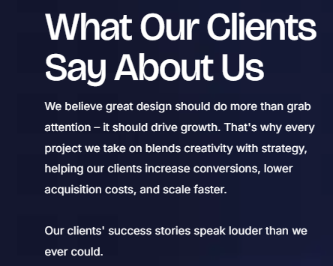

What Our Clients Say About Us
We believe it's important to understand our clients' goals and make their ideas a reality, and this is where great digital solutions start. Understand how our Web Development, Software Solutions, AI Automation and Digital Services enable businesses to advance.
“What ‘Ink Pixel Studio did, was exactly what we wanted and they were able to execute that exactly as our brand. They knew what we wanted, and they made it easy for us.”
“We required a software solution that fit our business operations and Ink Pixel Studio was able to accommodate our needs and make it a viable solution because they took a personal approach to us.”
“The team has made the process of developing the app smoother by keeping our end users and objectives in mind. We were impressed by their attention to detail and understanding of our goals.”
“Ink Pixel Studio guided us through strategies we could use to streamline repetitive tasks by making them automated; their suggestions helped us to see how technology could play a role in our workflow.”
“The collaborative nature of the team, their willingness to listen to our ideas, consider our feedback and strive to create a digital solution that fitted our business needs was what we valued the most.”
“Ink Pixel Studio was able to leave a positive impression as they worked with us from our initial needs through to the final solution, seeing how our technology could then work for us.”
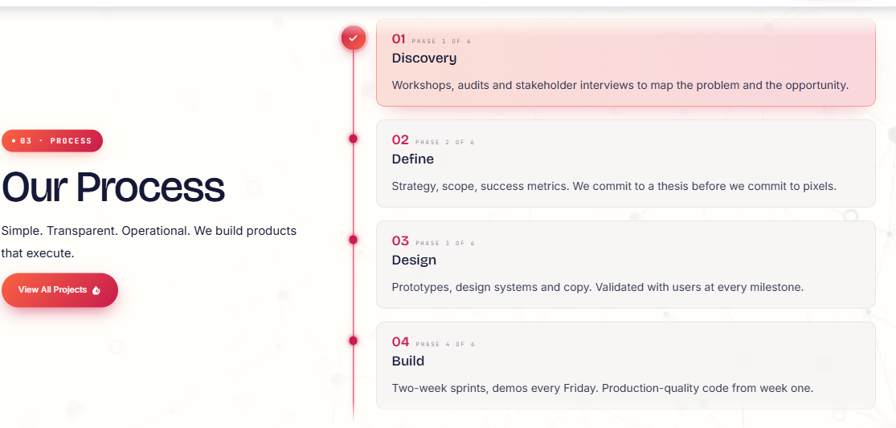

Built With Precision. Designed for Compliance.
Great technology requires great ideas. From strategic planning to secure engineering, thorough testing, continuous improvement, and more, we ensure that each solution is designed around your business goals, technical needs, security needs, and applicable industry standard.
01. Discover & Define
Before defining the right solution, we grasp your business, user, problems, targets, and technical needs.
02. Strategize & Architect
Our experts prepare the product roadmap, technology architecture, workflows and security aspects essential for large-scale product development.
03. Design & Develop
Using an agile development process, we turn the approved strategy into easy-to-use designs and strong digital products.
04. Test & Validate
Each solution is thoroughly quality checked, performed, tested for security and validated for quality and reliability.
05. Launch & Evolve
We deploy, monitor, troubleshoot and continually enhance your product throughout your business and technology evolution.
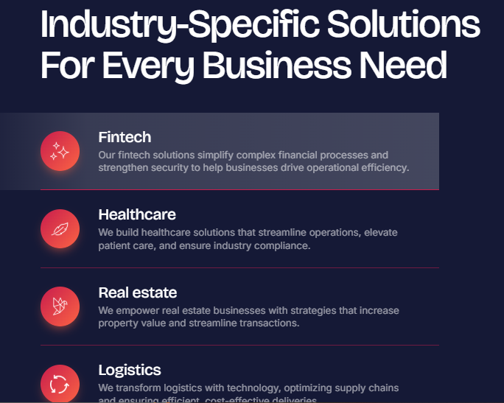

One Technology Partner. Solutions for all industries.
There are challenges, customers, rules and opportunities in each industry. Software solutions are provided specifically for your industry, to fit your business and to leave the space for innovation and growth.
FINTECH
We create secure fintech solutions, making financial services, payments, banking, lending and digital transactions easier and more secure, with scalability at the forefront.
HEALTHCARE
The healthcare technology solutions we offer bridge the gap between patients, providers and operations via secure digital platforms, fostering greater access, efficiency and experience.
REAL ESTATE
We build real estate tech solutions, from the process of discovering home, management, transactions, communication, to customer engagement.
ON DEMAND
We develop on-demand solutions that are scalable and bring customers to services fast via intuitive platforms with smart workflows and seamless digital experiences.
LOGISTICS
Our logistics software solution optimizes transportation, tracking, fleet operation, inventory and delivery process to enable businesses to move smarter.
ECOMMERCE
We develop eCommerce solutions that drive performance and deliver a compelling shopping journey, alongside smooth payment handling, engaging customer journeys and business expansion.

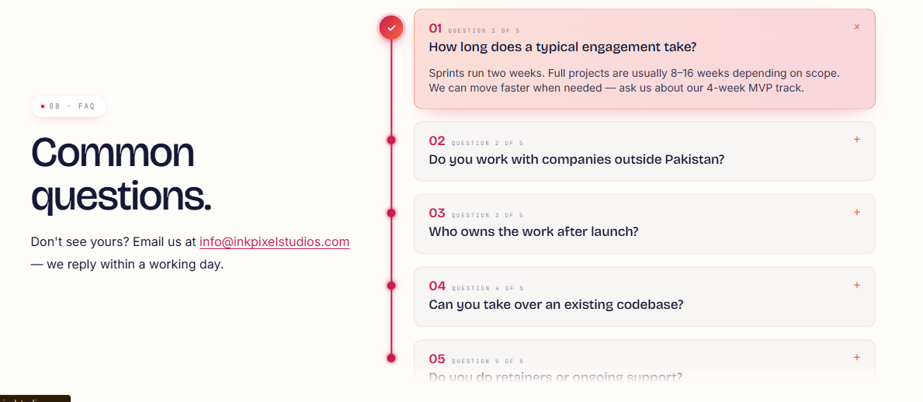

Frequently Asked Questions
- What services does Ink Pixel Studio provide?
Ink Pixel Studio offers a wide array of technology and digital solutions such as mobile app development, web development, custom software development, AI development, cloud services, blockchain development, game development, digital marketing, staff augmentation, and technology consulting.
- Are you able to build an app for iOS and Android?
Yes. Depending on the project needs, our mobile app development teams can create apps designed for iOS and Android, or build cross-platform apps, such as the ones built using Flutter and React Native.
- Will Ink Pixel Studio be able to create a custom software solution for my business?
Absolutely. Rather than putting your business into a “one size fits all” solution, we create custom software solutions tailored to your workflows, your users, your requirements for operation, and your business goals.
- Do you offer AI and automation solutions?
Yes. AI Development, AI Agent Development, Generative AI, Machine Learning, Natural Language Processing, Chatbots, and AI Automation Solutions to boost productivity, automate repetitive tasks, and optimize decision-making.
- Will you support us in moving our business to the cloud?
Yes. Our cloud services range from cloud migration, infrastructure migration, cloud application development, managed cloud services, serverless computing, DevOps enablement, cloud infrastructure and cloud cost optimization.
- Does your website offer follow up support after it's published?
Yes. App Support and Maintenance, Cloud Support, Software Maintenance, optimization, updates, troubleshooting and continuing technical help are all available to help maintain the security and performance of your digital product.
- Are you able to come up with ideas for particular industries?
Yes. We develop industry specific technology solutions for industries such as fintech, healthcare, real estate, e-commerce, retail, logistics, telecom, construction and on-demand.

Service Pages

Branding Page
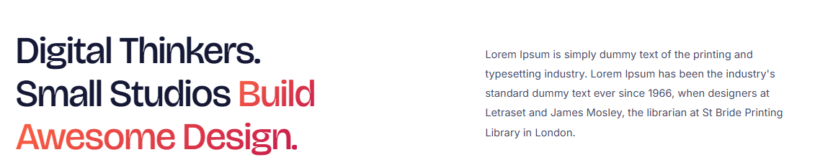

Avail Our Branding Services to Stand Out!
Ink Pixel Studio is a company that offers branding solutions to your business to make it stand out and make it last long. From brand identity design to logo design, marketing visuals to brand strategy, we make sure that every aspect is aligned with your vision and resonates with your target audience. Select us for creativity, individual solution and perfectionism. We aren't just about creating beautiful designs, making your business more visible, letting people know what you stand for, and making a mark for your brand, we're about creating memorable, cohesive brands.

Brand Identity / Logo Design


Brand Identity & Logo Design
Ink Pixel Studio creates a memorable impression with your brand identity design and creative logo design services. Whether it's logos, color schemes, typography, or any other aspect of the visual brand, we produce design systems that are unified and aligned with your business principles and your audience. We're not afraid to think outside the box and work with market research so that you'll stand out in today's competitive marketplace.
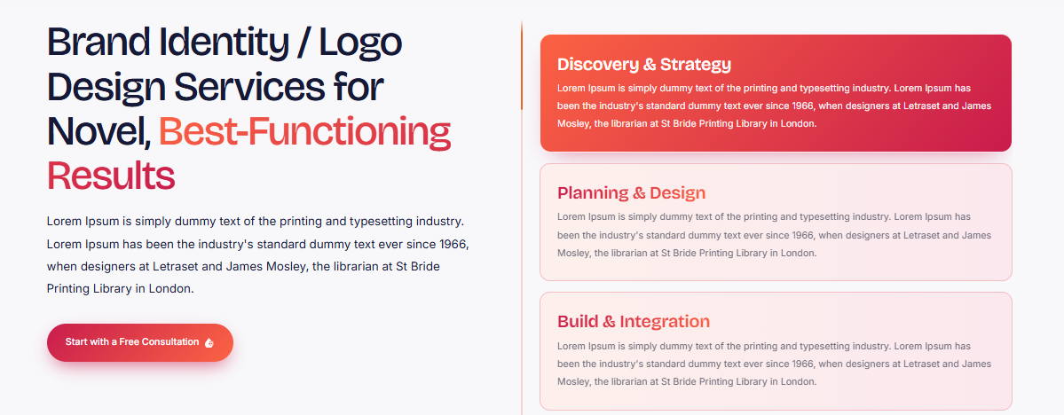

Why choose us?
We don't just work on a pretty picture, we work on a strong brand identity that conveys your message, enhances brand recognition and creates a seamless experience on both digital and print. The thing that sets us apart is our personalized approach to design, attention to detail and our focus on directing every creative choice to your corporate objectives. From start-ups to established businesses, our custom branding services ensure you create a memorable, unique, and professional brand.
- Discovery & Consultation: We know your business, audience, objectives, and brand vision.
- Research & Strategy: We conduct research on your industry, competition, and market trends to establish your brand's visual direction.
- Concept Development: We develop initial logo concepts, focusing on typography, color schemes, symbols and design styles that are appropriate to your brand.
- Refinement & Feedback: This is where we take the feedback from you and make the chosen concept more refined in order to make it fit your needs.
- Finalization & Delivery: Your finalized logo and agreed upon brand identity elements that can be used across your website, social media, marketing materials, etc.

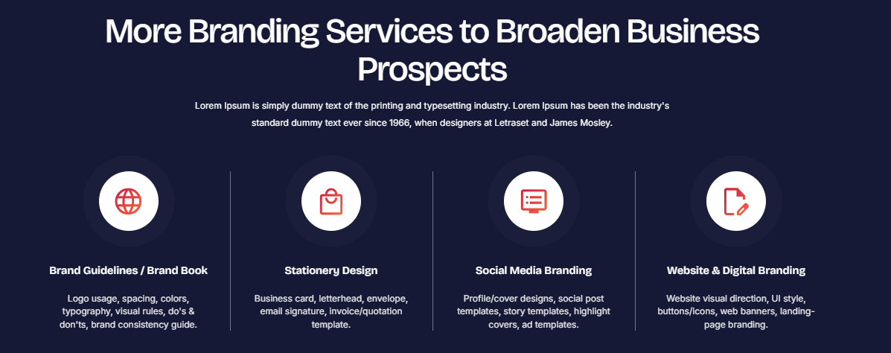

We Offer Our Customers with A Variety of Brand Identity Services
Our bespoke brand identity solutions will ensure your brand identity is cohesive and memorable, at every customer touchpoint.
- Brand Guidelines / Brand Book
Create a visual identity by providing detailed brand guidelines for logo usage, color schemes, typography and brand elements.
- Stationery Design
Create a good first impression with branded business stationery, business cards, letterheads, envelopes, and more.
- Social Media Branding
Develop a consistent and recognizable online brand identity by using consistent templates, profile pictograms, and graphics on social media platforms.
- Website & Digital Branding
Develop a unified digital identity through website branding, with visual elements, typography, colors and digital assets that are associated with your identity.

Stationery Design


Stationery Design Services
At Ink Pixel Studio, we will help you get the professional business stationery design that can make a lasting impression and make it appear as if your business logo is on it. Whether you're looking for business cards, letterheads, envelopes, custom folders, or even branded company stationery, our custom stationery design services will ensure that all of your elements are in harmony with your business image. We meet the needs of creativity, consistency, and functionality to generate stationery with credibility and professionalism.
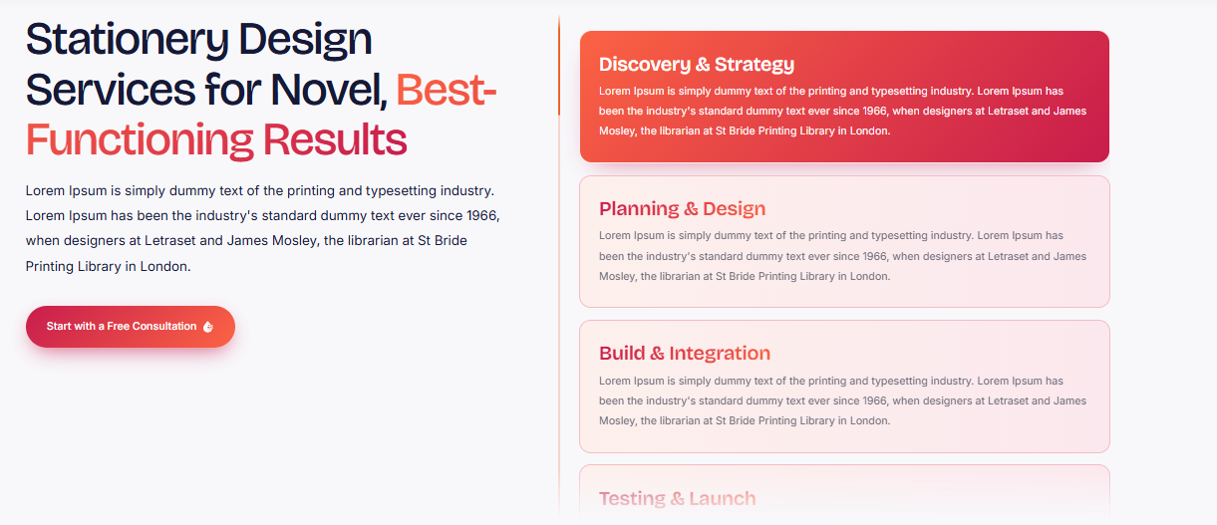

Why choose us?
Each design is customized to your brand, audience, and business goals. The difference is our sensitivity and dedication to uniformity of visuals throughout all your branded products. From establishing a brand-new business to refreshing the identity of your current company, our team can help you create stationery that's a real branding touch for increased recognition and trust in your clients.
1. Discovery & Strategy: Firstly, we learn about your business, target audience, brand identity and stationery needs.
2. Brand Assessment: We analyze your current logo, colors, typography and brand rules to ensure the consistency of the design.
3. Concept & Design: We create unique custom stationery designs that are perfectly suited to your business vision and branding.
4. Review & Refinement: We take your input and make the changes to the layouts, typography, colors and detail.
5. Finalization & Delivery: We send the approved print-ready stationery designs and agreed upon digital files, which can be used professionally.

We Offer Our Customers with A Variety of Brand Identity Services
Our bespoke brand identity solutions will ensure your brand identity is cohesive and memorable, at every customer touchpoint.
- Brand Guidelines / Brand Book
Create a visual identity by providing detailed brand guidelines for logo usage, color schemes, typography and brand elements.
- Stationery Design
Create a good first impression with branded business stationery, business cards, letterheads, envelopes, and more.
- Social Media Branding
Develop a consistent and recognizable online brand identity by using consistent templates, profile pictograms, and graphics on social media platforms.
- Website & Digital Branding
Develop a unified digital identity through website branding, with visual elements, typography, colors and digital assets that are associated with your identity.

Website and Digital Branding


Website & Digital Branding Services
Our strategic website and digital branding services at Ink Pixel Studio empower businesses to build a strong online footprint. Whether it's your website design, graphics, branding colors, fonts, or digital marketing pieces, we make sure everything is consistent and represents your brand. With our digital brand design, you'll have a consistent experience whether you're on a website, social media, or other digital touchpoint.
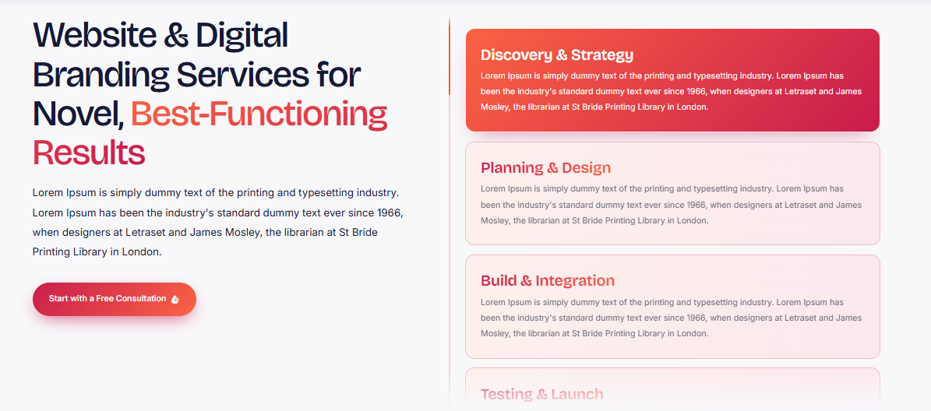

Why choose us?
With our creative design, you get a unique and engaging online identity that your customers will recognize your business by. We are different because we are highly personalized, we ensure a visual consistency and because we aim to create digital experiences that convey your brand's values, not just chasing design trends. We help you make a splash, establish and reinforce brand identity and foster meaningful relationships with your audience, whether you are building a new site or refreshing your digital presence.
- Discovery & Consultation: We listen to your business goals, audience, brand persona, and digital needs.
- Research & Brand Strategy: Analyze your industry and competitors and set your digital branding direction.
- Visual concept development: We create website branding elements such as color palette, typography, graphics, and digital assets that align with your brand.
- Design & Refinement: We make your design and images even better according to your feedback so it becomes consistent across the digital platforms.
- Finalization & Implementation: We provide you with the final digital branding assets and implement the approved designs on your website and digital assets, ensuring a unified digital brand.
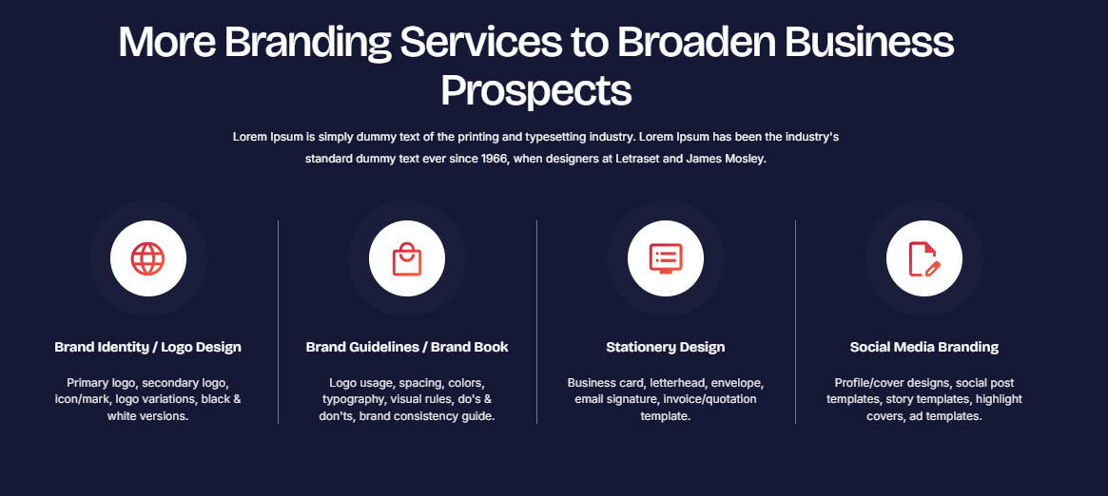

We Offer Our Customers with A Variety of Brand Identity Services
Our bespoke brand identity solutions will ensure your brand identity is cohesive and memorable, at every customer touchpoint.
- Brand Identity / logo Design
From brand identity design to logo design, marketing visuals to brand strategy, we make sure that every aspect is aligned with your vision and resonates with your target audience.
- Stationery Design
Create a good first impression with branded business stationery, business cards, letterheads, envelopes, and more.
- Social Media Branding
Develop a consistent and recognizable online brand identity by using consistent templates, profile pictograms, and graphics on social media platforms.
- Website & Digital Branding
Develop a unified digital identity through website branding, with visual elements, typography, colors and digital assets that are associated with your identity.

Brand Guidelines / Brand Book


Brand Guidelines / Brand Book Services
Businesses need to be consistent and recognizable and at Ink Pixel Studio, we can help you design brand guidelines and a brand book that will guide you to that. Brand style guides outline usage of your logo, font, color scheme, photography and graphics in your marketing and digital communications. We develop bespoke branding guidelines, aligning your brand with your values and maintaining brand consistency at all customer interactions.
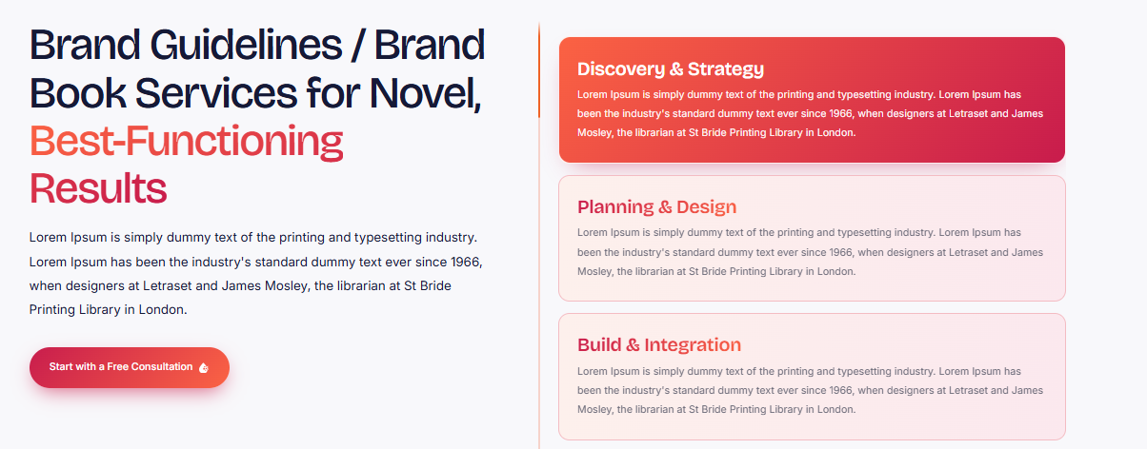

Why choose us?
We translate your brand vision into a long-term brand recognizable visual framework that's easy to follow. Our difference is working with you on individual basis, paying attention to detail and designing guidelines that are esthetically pleasing and functional.
1. Brand Discovery: We learn about your business, audience, values, goals, and existing brand identity.
2. Brand Audit & Research: We review your current branding and identify the elements that need consistency or refinement.
3. Guideline Development: We define logo usage, typography, color palettes, imagery, and visual standards.
4. Design & Review: We organize the guidelines into a clear, visually engaging document and refine it using your feedback.
5. Finalization & Delivery: We deliver your completed brand book in an accessible digital format, ready to guide future branding and marketing efforts.

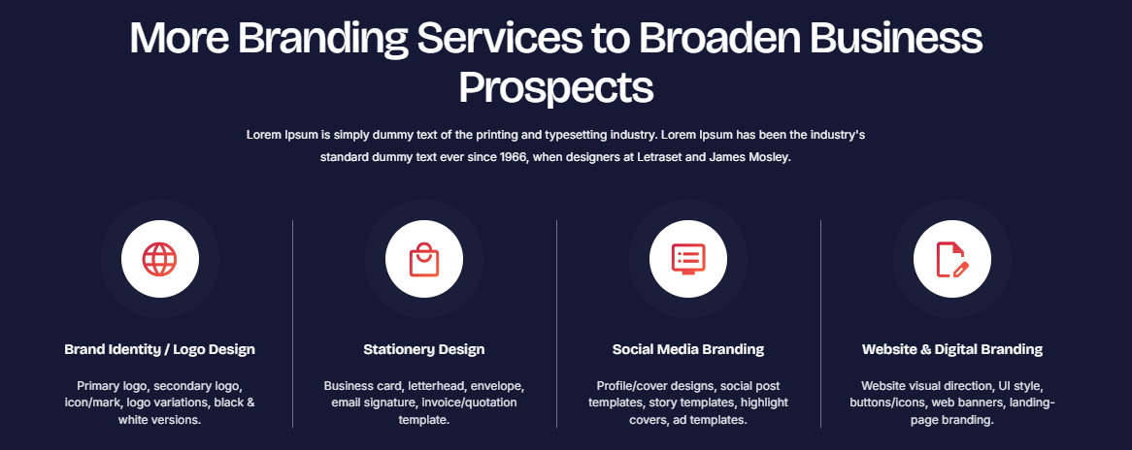

We Offer Our Customers with A Variety of Brand Identity Services
Our bespoke brand identity solutions will ensure your brand identity is cohesive and memorable, at every customer touchpoint.
- Brand Identity / logo Design
From brand identity design to logo design, marketing visuals to brand strategy, we make sure that every aspect is aligned with your vision and resonates with your target audience.
- Stationery Design
Create a good first impression with branded business stationery, business cards, letterheads, envelopes, and more.
- Social Media Branding
Develop a consistent and recognizable online brand identity by using consistent templates, profile pictograms, and graphics on social media platforms.
- Website & Digital Branding
Develop a unified digital identity through website branding, with visual elements, typography, colors and digital assets that are associated with your identity.

Social Media Branding


Social Media Branding Services
Strategic social media branding services are what Ink Pixel Studio can help you with to help businesses create a recognizable online presence. We develop consistent designs for your brand, including branded post templates, profile graphics, story designs, cover images and platform specific graphics. We have brand identity solutions for social media, including Facebook, Instagram, LinkedIn, and other social media sites.
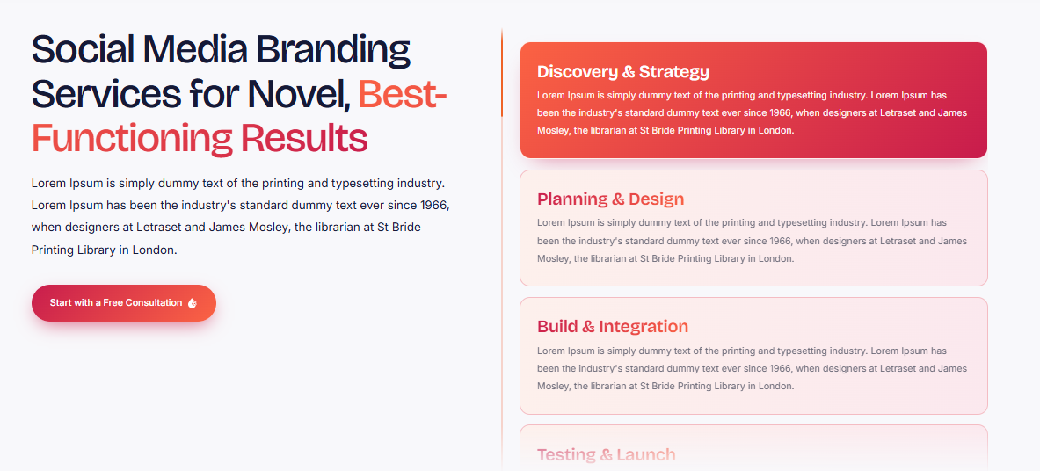

Why choose us?
We blend creativity with your business goals to create graphics that will resonate and enhance your brand's visibility. The extra touch that makes us different is our ability to create branding that's unique to you, rather than using templates, and our focus on visual consistency. You can use our social media branding service for new brands or for existing brands to refresh their social media look and feel.
1. Discovery & Consultation: We get to know your brand, audience, objectives and social media of choice.
2. Brand Research & Strategy: we evaluate your industry, your competition and existing visuals to define a unique brand direction.
3. Visual Concept Development: We produce brandable social media templates, profile graphics, cover images and other visuals.
4. Design Review & Refinement: We take your feedback and make improvements to designs to align with your brand.
5. Finalization & Delivery: We share the approved social media branding elements in platform-appropriate formats to help build a consistent online brand.
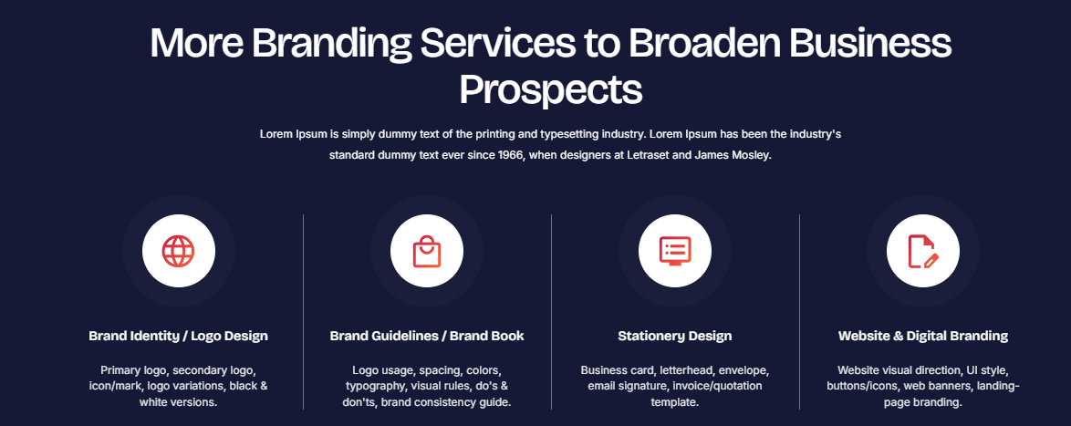

We Offer Our Customers with A Variety of Brand Identity Services
Our bespoke brand identity solutions will ensure your brand identity is cohesive and memorable, at every customer touchpoint.
- Brand Identity / logo Design
From brand identity design to logo design, marketing visuals to brand strategy, we make sure that every aspect is aligned with your vision and resonates with your target audience.
- Stationery Design
Create a good first impression with branded business stationery, business cards, letterheads, envelopes, and more.
- Social Media Branding
Develop a consistent and recognizable online brand identity by using consistent templates, profile pictograms, and graphics on social media platforms.
- Website & Digital Branding
Develop a unified digital identity through website branding, with visual elements, typography, colors and digital assets that are associated with your identity.

Brand Launch & Implementation


Brand Launch & Implementation Services
Ink Pixel Studio specializes in brand identity launch and implementation to help businesses get a new product to the market with their brand. Whether you need help with establishing your visual presence on multiple platforms or creating and editing the assets you'll need for your marketing campaign, we have you covered. Our brand implementation process ensures that your logo, messaging, website, social media and your promotional tools are all in line with your business objectives.
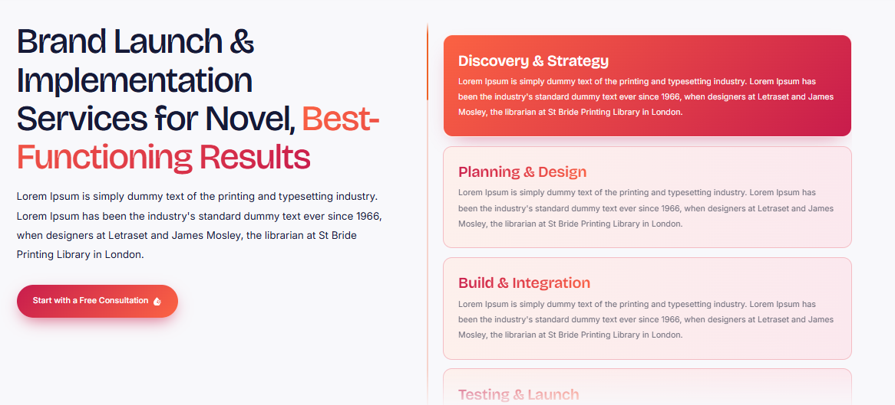

Why choose us?
We take an innovative, organized and customized approach on each brand launch. The things that make us so special is that we are not just about launch day; it's about keeping your brand consistent as you grow. Taking either a start-up or a rebranded business to market, our brand launch solutions ensure that your value is communicated, your brand is recognized and you lay a solid foundation for future success.
1. Design & Consultation: We get to know what you are looking to achieve, where you are targeting your audience, what you want to achieve upon launch, and how you want your brand positioned.
2. Strategy Development: We provide information on essential launch activities, platforms, timelines and branding assets.
3. Asset Preparation: We create brand launch assets like digital graphics, website visuals, social media graphics, and promotional designs.
4. Brand Implementation: We are consistent with your approved identity, across the agreed digital and marketing touch points.
5. Review & Optimization: Brand Consistency review, feedback and opportunities to enhance your brand's market presence.
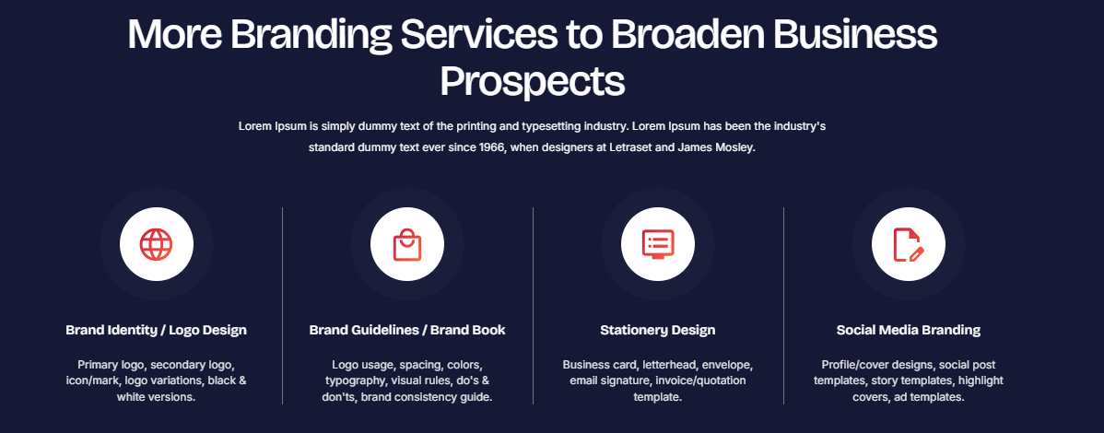

We Offer Our Customers with A Variety of Brand Identity Services
Our bespoke brand identity solutions will ensure your brand identity is cohesive and memorable, at every customer touchpoint.
- Brand Identity / logo Design
From brand identity design to logo design, marketing visuals to brand strategy, we make sure that every aspect is aligned with your vision and resonates with your target audience.
- Stationery Design
Create a good first impression with branded business stationery, business cards, letterheads, envelopes, and more.
- Social Media Branding
Develop a consistent and recognizable online brand identity by using consistent templates, profile pictograms, and graphics on social media platforms.
- Website & Digital Branding
Develop a unified digital identity through website branding, with visual elements, typography, colors and digital assets that are associated with your identity.

Development
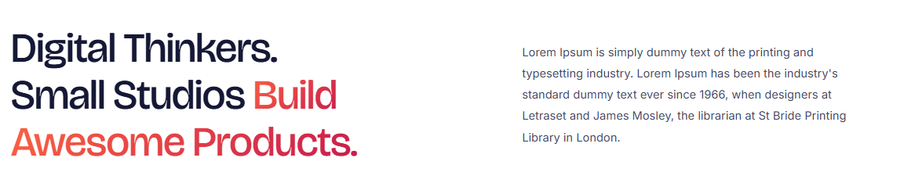

Why choose our Development Services?
Our creative approach, technical expertise, and client-centric thinking enable us to create functional, user-friendly digital experiences. The key thing about us is that we do not have a normal service offering; we know how to understand your specific needs, and we do not offer a solution that fits everyone. We develop digital solutions that grow with your business, optimize performance, and are mobile responsive.


Web Development Services
At Ink Pixel Studio, we create impactful digital experiences with custom web development solutions that align with your business objectives. Whether you're looking for a responsive business website, a dynamic web application, or a feature-packed ecommerce platform, our custom web development solutions deliver both functionality and usability, coupled with a modern design that looks the part. We're concerned with making your site mobile friendly, optimizing your website for performance and making it easy to navigate so that your site will work well on your mobile device.
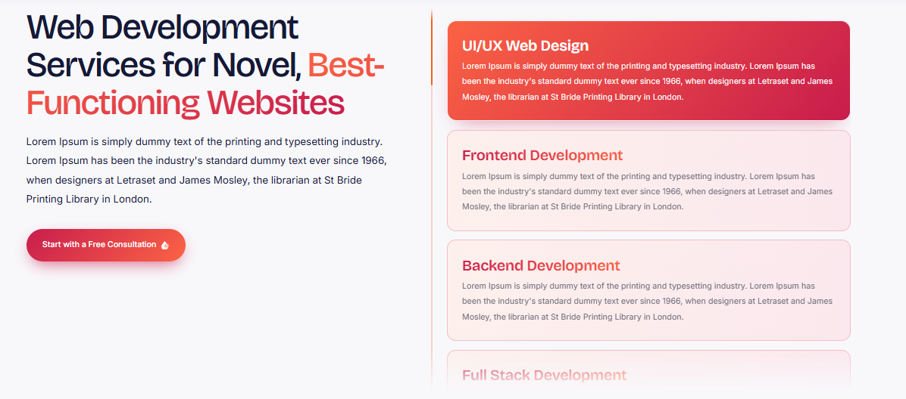

Why choose us?
We listen to your audience, goals, and technical needs and create a solution for you. Our difference is that we don't use a 'one-size-fits-all' solution, something that's specific and thorough to the details, and we only build scalable websites. From launching new businesses to upgrading current websites, we build them with the ability to bolster your online presence and pave the way for long-term growth.
1. Discovery & Planning: We talk through your business objectives, your audience, what your website needs to be like, what you want it to do.
2. Structure & Design: We design the website structure, navigation and visual components to ensure intuitive user experience.
3. Web Development: Your website is created with appropriate technologies, keeping the elements of responsive design, functionality and performance in mind.
4. Testing & Optimization: Testing of features, browser compatibility, mobile friendly, loading speed and usability of the website in order to identify issues.
5. Launch & Support: We launch and support your approved website and help keep it running smoothly as agreed.
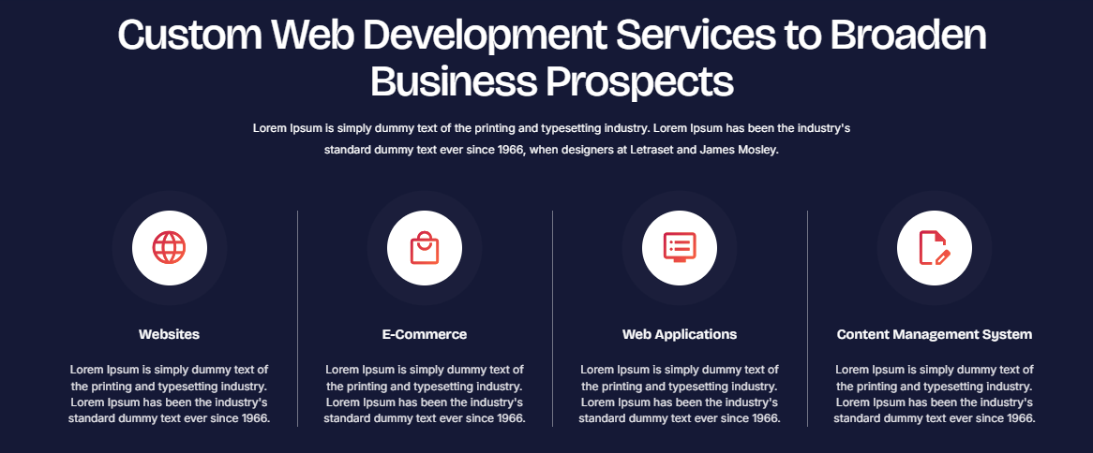

Broaden Your Businesses with Our Different Services
Learn about custom web development solutions that can enhance your website's visibility, user-friendliness, and ability to drive business growth. Ink Pixel Studio offers a blend of cutting-edge technology and a personalized touch, developing digital solutions with your objectives in mind.
- Websites
We develop responsive business websites that are engaging and informative, convey your brand message and provide seamless web browsing experience across devices.
- E-Commerce
We provide eCommerce website development solutions that enable businesses to create an online store that is easy to navigate, showcases products, and offers a smooth shopping experience.
- Web Applications
We build tailor-made Web Apps that streamline processes, make things accessible and resolve your business problems.
- Content Management System
With our CMS development services, you can easily manage, update and organize the content on your website without having to be an expert in technical matters.

CMS Development


CMS Development Services
Unlike generic CMS development solutions, Ink Pixel Studio offers customized services to make web management a breeze, providing businesses with more control over their digital content. Whether it's a custom WordPress site, or a flexible CMS website, we deliver solutions that allow easy updating of pages, publishing blogs, and handling media. Our custom CMS solutions are built around your workflows, using easy-to-use dashboards, responsive design, security and scalability.
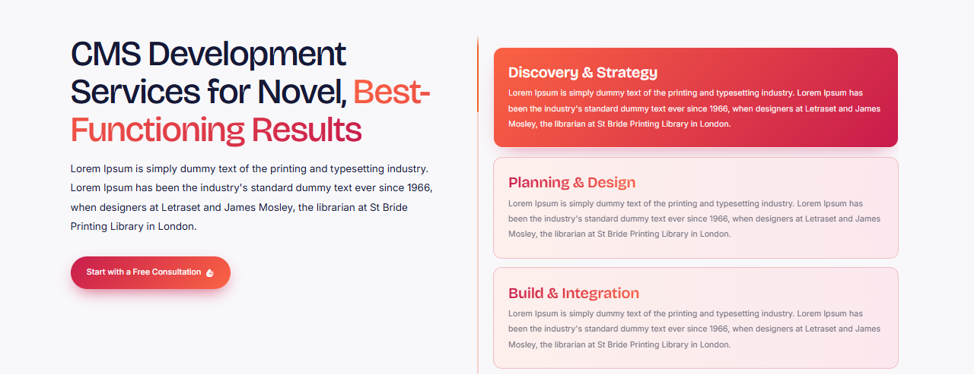

Why choose us?
Our emphasis is on developing practical, efficient, business-appropriate content management systems. The difference with us is personalization; we aren't going to force your business into a structure that doesn't suit your content and your future needs.
1. Requirement Analysis: We assess your business objectives, content needs, user roles, and website requirements.
2. CMS Planning: We select a suitable content management platform and map out the website structure, features, and workflows.
3. Design & Development: We build and customize your CMS with intuitive dashboards, responsive layouts, and required functionality.
4. Testing & Optimization: We test usability, performance, security, and compatibility across devices and browsers.
5. Launch & Handover: We deploy your CMS, provide guidance on content management, and offer agreed-upon post-launch support.
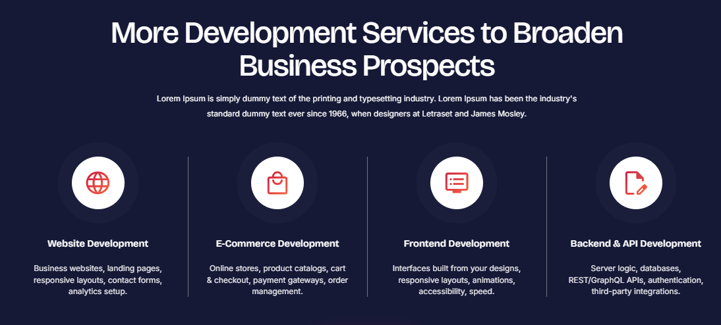

Broaden Your Businesses with Our Different Services
Learn about custom web development solutions that can enhance your website's visibility, user-friendliness, and ability to drive business growth. Ink Pixel Studio offers a blend of cutting-edge technology and a personalized touch, developing digital solutions with your objectives in mind.
- Websites
We develop responsive business websites that are engaging and informative, convey your brand message and provide seamless web browsing experience across devices.
- E-Commerce
We provide eCommerce website development solutions that enable businesses to create an online store that is easy to navigate, showcases products, and offers a smooth shopping experience.
- Frontend Development
We build engaging, responsive frontend interfaces using modern web technologies to ensure your website looks great and works smoothly across devices.
- Backend & API Development
Our backend development and API integration services power your website behind the scenes, managing databases, business logic, user authentication, and communication between applications.

Backend & API Development


Backend & API Development
At Ink Pixel Studio we create the technology that empowers the seamless digital experience with reliable backend development and API development services. Whether it's database management, server-side programming, secure authentication, or third-party integration, our solutions ensure that your website or application runs smoothly and efficiently behind the scenes. We offer custom backend development services to facilitate business processes and API integration solutions to ensure seamless communication between platforms, applications and external services.
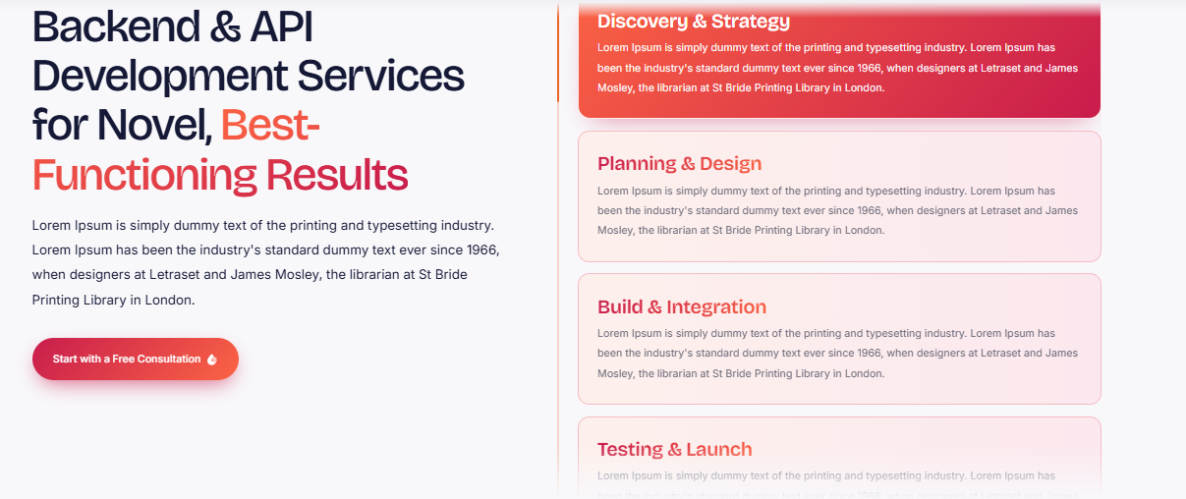

Why choose us?
Our emphasis is on developing secure, efficient and scalable systems to meet your technical needs. We're different because we take a personal approach to development, function, and cater to solutions that can grow with your business as it changes. From new application development to optimizing existing systems, we provide the strong technical base that enables sustained digital growth.
1. Requirements Analysis: We determine your business needs, application features, data requirements and integration requirements.
2. Architecture & Planning: Backend architecture, Database structure, API endpoints, security requirements.
3. Backend & API Development: We create server-side functionality, database operations, authentication, and necessary API integrations.
4. Testing & Security: We then test API responses, system performance, data handling & security to find and fix problems.
5. Deployment & Support: We deploy the agreed solution, test the system and offer agreed support & maintenance.
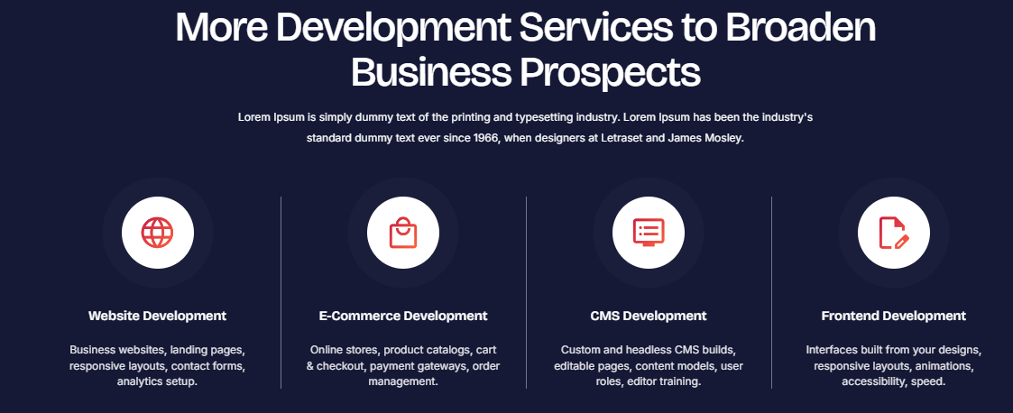

Broaden Your Businesses with Our Different Services
Learn about custom web development solutions that can enhance your website's visibility, user-friendliness, and ability to drive business growth. Ink Pixel Studio offers a blend of cutting-edge technology and a personalized touch, developing digital solutions with your objectives in mind.
- Websites
We develop responsive business websites that are engaging and informative, convey your brand message and provide seamless web browsing experience across devices.
- E-Commerce
We provide eCommerce website development solutions that enable businesses to create an online store that is easy to navigate, showcases products, and offers a smooth shopping experience.
- Frontend Development
We build engaging, responsive frontend interfaces using modern web technologies to ensure your website looks great and works smoothly across devices.
- Backend & API Development
Our backend development and API integration services power your website behind the scenes, managing databases, business logic, user authentication, and communication between applications.

E-Commerce Development


E-Commerce Development
Create products and make them available online with our custom ecommerce website development services at Ink Pixel Studio. Whether it's designing bespoke eCommerce platforms or connecting secure payment processors, product catalogs, and inventory systems, we deliver smooth shopping journeys which make it easier for the buyers to buy. We specialize in creating responsive, easy-to-navigate and user-friendly e-commerce experiences that help achieve customer satisfaction and business growth.
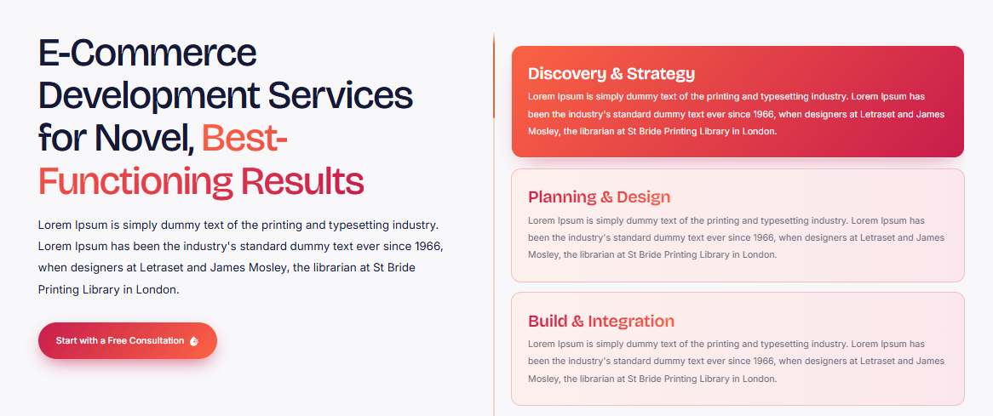

Why choose us?
Our creative design combines with functional usability to create online stores that are in line with the goals of your business. Our uniqueness lies in the personal touch, understanding of the customer journey, and flexibility and scalability of our solutions as opposed to just a storefront. From starting an online business to updating your store, we can help you create a strong online presence that can help your brand grow.
1. Discovery & Planning: Our team understands what products you are looking for, your customers, your goals and your store needs.
2. Product Categories, Layout, Navigation, Shopping Experience: We plan product categories, layout, navigation, and smooth shopping experience.
3. Development & Integration: We create your e-commerce platform and connect all essential elements like payment gateways, inventory systems and shipping options.
4. Testing & Optimization: Testing checkout functionality, mobile responsiveness, website speed and payment processes.
5. Launch & Support: We launch your approved online store and support agreed with you to ensure that your store performs to best of its ability.

Broaden Your Businesses with Our Different Services
Learn about custom web development solutions that can enhance your website's visibility, user-friendliness, and ability to drive business growth. Ink Pixel Studio offers a blend of cutting-edge technology and a personalized touch, developing digital solutions with your objectives in mind.
- Websites
We develop responsive business websites that are engaging and informative, convey your brand message and provide seamless web browsing experience across devices.
- E-Commerce
We provide eCommerce website development solutions that enable businesses to create an online store that is easy to navigate, showcases products, and offers a smooth shopping experience.
- Frontend Development
We build engaging, responsive frontend interfaces using modern web technologies to ensure your website looks great and works smoothly across devices.
- Backend & API Development
Our backend development and API integration services power your website behind the scenes, managing databases, business logic, user authentication, and communication between applications.

Front End Development


Front End Development
At Ink Pixel Studio, we make designs come alive with a custom frontend development service. We develop your website using fresh HTML, CSS, JavaScript and the latest front-end frameworks to create responsive and attractive interfaces, optimizing website performance and compatibility across devices. Whether it's interactive web pages or user interfaces that are dynamic, we always focus on usability, accessibility, and performance in our custom frontend development solutions.
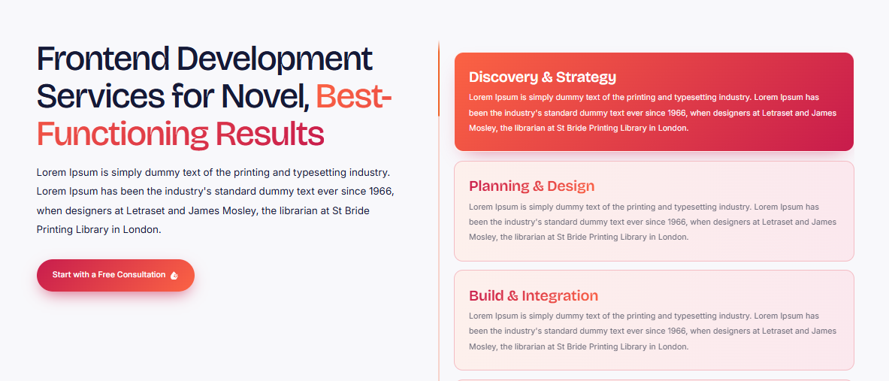

Why choose us?
We prioritize user experience and ensure that our interfaces are not only aesthetically pleasing but also intuitive and easy to use. We're different because we go the extra mile, especially when it comes to building interfaces that are personalized, detailed and completely aligned with your brand and business objectives. From new website builds to enhancements to your existing application, we create smooth user experiences (UX) to ensure that your business gets a great impression online.
1. Requirement Analysis: We know your objectives, your target audience, your design requirements and your functional requirements.
2. UI Planning: We design pages, user flows and interactive components to ensure a seamless user experience.
3. Frontend Coding: We convert approved designs into working interfaces using appropriate frontend technologies and responsive coding of the interface.
4. Test & Optimization: We test responsiveness, browser compatibility, accessibility, and loading performance on a wide variety of devices.
5. Deployment & Review: We deploy the agreed interface and test it for working and agree to support the improvement of the working interface.

Broaden Your Businesses with Our Different Services
Learn about custom web development solutions that can enhance your website's visibility, user-friendliness, and ability to drive business growth. Ink Pixel Studio offers a blend of cutting-edge technology and a personalized touch, developing digital solutions with your objectives in mind.
- Websites
We develop responsive business websites that are engaging and informative, convey your brand message and provide seamless web browsing experience across devices.
- E-Commerce
We provide eCommerce website development solutions that enable businesses to create an online store that is easy to navigate, showcases products, and offers a smooth shopping experience.
- Frontend Development
We build engaging, responsive frontend interfaces using modern web technologies to ensure your website looks great and works smoothly across devices.
- Backend & API Development
Our backend development and API integration services power your website behind the scenes, managing databases, business logic, user authentication, and communication between applications.

Maintenance & Support

Our website maintenance and support services at Ink Pixel Studio ensure your website remains secure, reliable, and functioning smoothly, keeping your business online. We will take care of your website's normal software updates, bug fixes, security monitoring, performance optimization and troubleshooting to help ensure that it continues to meet your business requirements. Our Website Support Services are devoted to reducing disruptions, optimizing functionality and ensuring a smooth user experience.
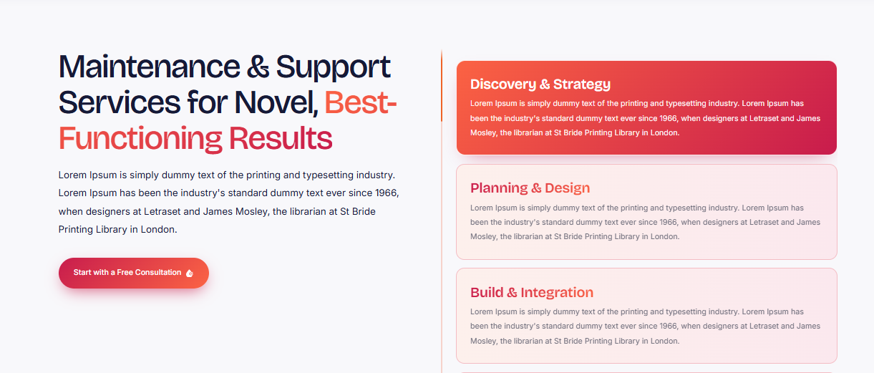

Why choose us?
We are proactive and ensure that potential issues are identified and addressed in a personalized manner before it impacts your users. We're unique in focusing on reliability over the long term, clear communication, and support that is specific to your website's requirements. From maintenance to technical support or performance enhancements, we ensure that your website continues to be a valuable asset that supports your growing business, and that your digital investment is properly safeguarded.
1. Website Assessment: Checking the condition, function, performance and maintenance of your website.
2. Maintenance Planning: We create a customized maintenance plan including updates, backup, security checks, and support priorities.
3. Updates & Improvements: We make website updates for reliability, fix bugs and technical issues.
4. Testing & Monitoring: We test the website for its performance, security, responsiveness and important features to find potential issues.
5. Ongoing Support: We provide technical support and maintenance agreed upon with you to help your website to keep running, safe and updated.

Broaden Your Businesses with Our Different Services
Learn about custom web development solutions that can enhance your website's visibility, user-friendliness, and ability to drive business growth. Ink Pixel Studio offers a blend of cutting-edge technology and a personalized touch, developing digital solutions with your objectives in mind.
- Websites
We develop responsive business websites that are engaging and informative, convey your brand message and provide seamless web browsing experience across devices.
- E-Commerce
We provide eCommerce website development solutions that enable businesses to create an online store that is easy to navigate, showcases products, and offers a smooth shopping experience.
- Frontend Development
We build engaging, responsive frontend interfaces using modern web technologies to ensure your website looks great and works smoothly across devices.
- Backend & API Development
Our backend development and API integration services power your website behind the scenes, managing databases, business logic, user authentication, and communication between applications.

Marketing
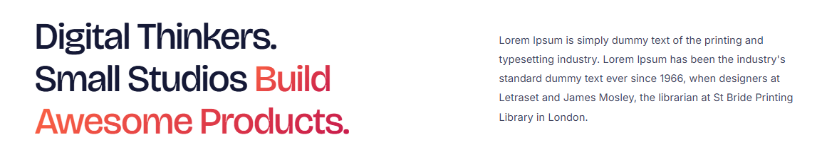

Why choose our Marketing Services?
We create with the data in mind and we make sure that it reaches the right people. We're unique in our ability to tailor our approach to your business, in our focus on results, and in our dedication to customizing each campaign to your specific business goals, not using generic marketing techniques. We create solutions to enhance brand visibility, attract potential customers, and boost business growth, including social media marketing, search engine optimization (SEO), Google Ads, and targeted advertising campaigns.

Social Media Marketing


Social media marketing services
Ink Pixel Studio is dedicated to helping businesses create meaningful connections online through innovative social media marketing solutions designed for businesses and their audience. Our social media solutions encompass social media strategy, content planning, social media management, engaging with the audience and paid promotions, all aimed at improving the visibility of your brand on platforms such as Facebook, Instagram, LinkedIn and others. We focus on consistent communications, engaging content and data-driven decisions to support sustainable growth in our social media management services.
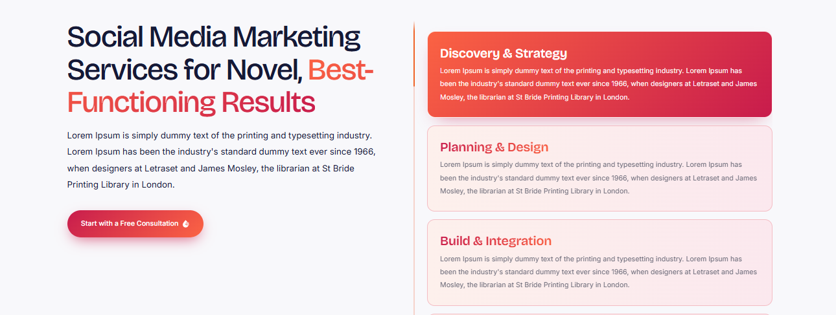

Why choose us?
We utilize creative storytelling and strategic planning to ensure that your brand resonates with the appropriate audience. Our uniqueness is in our personalized strategies, attention to your brand identity and our emphasis on meaningful engagement, not more posts. From new-focused brands to improving social media campaigns, we help you make your social media channels a valuable asset to your business.
1. Design & Consultation: First, we define your business goals, your target users and your preferred social media channels.
2. Strategy Development: We develop a personalized social media marketing strategy for your goals, industry, and behavior of your audience.
3. Content Planning & Creation: We create engaging posts, captions, graphics, and come up with a content calendar.
4. Campaign Management & Engagement: We manage scheduled content, monitor interactions, and optimize campaigns based on performance.
5. Performance Analysis & Reporting: We analyze important metrics, are able to review results and make recommendations to improve future social media campaigns.
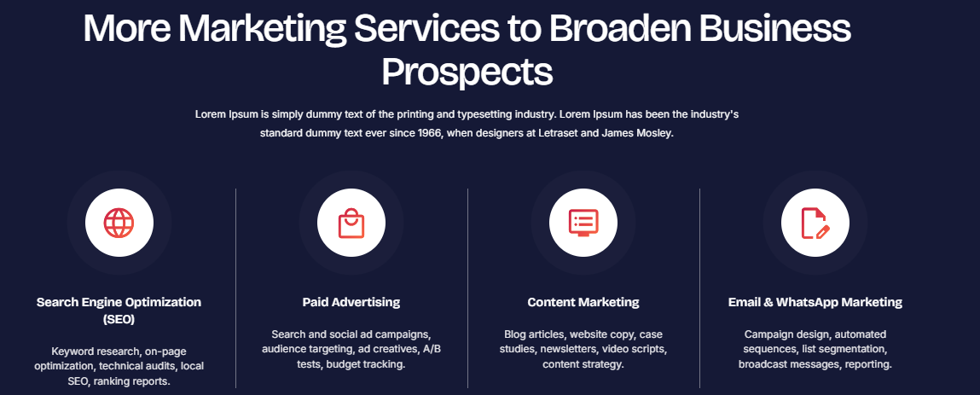

Broaden Your Businesses with Our Digital Marketing Services
Ink Pixel Studio is a digital marketing agency that provides custom-made solutions to assist businesses in becoming more visible and attracting a more targeted audience while fostering long-term customer connections.
- Search Engine Optimization (SEO)
Get your website optimized for search engines to boost its visibility, covering keyword research, on page optimization, technical optimization and content optimization.
- Paid Advertising
Connect with target audiences via relevant paid advertising like Google Ads and social media ads based on business goals, reach, frequency, and targets.
- Content Marketing
Engage customers with the right content marketing services, such as blogs, website content, social media and useful brand resources.
- Email & WhatsApp Marketing
Improve customer relations by engaging them with tailored email marketing and WhatsApp marketing messages, which convey updates and offers and cultivate leads.

Paid Advertising Services


Paid Advertising Services
Ink Pixel Studio offers strategic paid ads services that can help your business connect with the right people and yield relevant results. Whether you need Google Ads management or PPC advertising, Facebook and Instagram ads, we're able to develop targeted campaigns that will increase your brand visibility, attract quality leads, and help you convert them. Each of our paid digital marketing solutions is built around the concept of optimizing campaigns to better target your audience, craft compelling ads, perform keyword research, and save money.
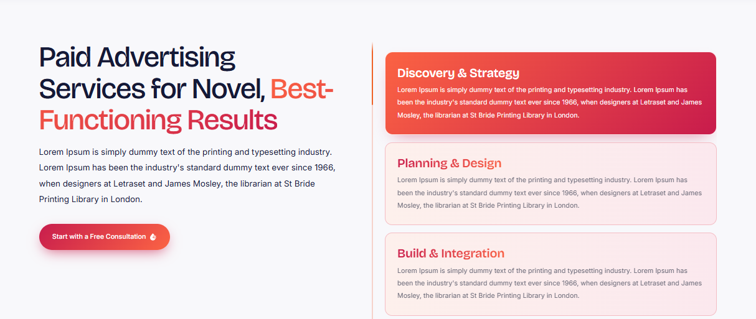

Why choose us?
We use creativity and data-based decisions to match your business goals with advertising. Our unique approach is to customize a strategy, continually monitor the campaigns, and never chase clicks, just results. We create advertising campaigns for various markets and growth objectives, whether you're seeking to promote a product, generate leads, or expand your market.
1. Goal setting & consultation: We define your business goals, target, budget & campaign outcomes.
2. Audience & Keyword Research: Conducting audience research and keyword research.
3. Campaign Setup & Ad Creation - We create and configure advertising campaigns and produce engaging ad copy and creatives that resonate with your audience.
4. Monitoring & Optimization: We track campaign performance and optimize the targeting, bidding and creatives to enhance performance.
5. Reporting & Improvement: We look at critical metrics like clicks, conversions, cost per lead, etc., to inform paid campaigns and provide improvement chances.
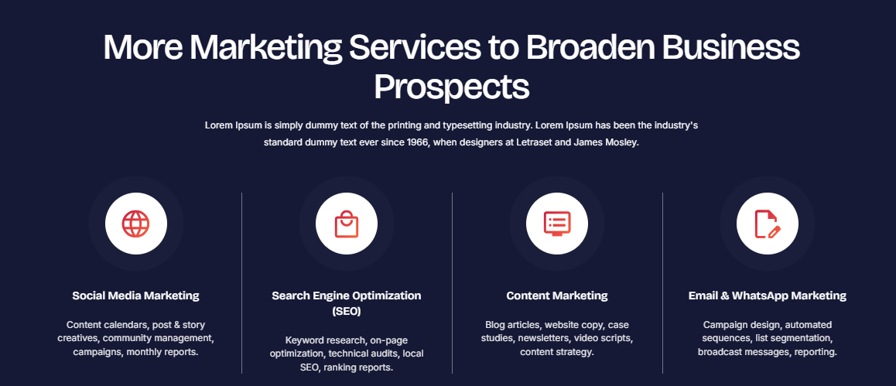

Broaden Your Businesses with Our Digital Marketing Services
Ink Pixel Studio is a digital marketing agency that provides custom-made solutions to assist businesses in becoming more visible and attracting a more targeted audience while fostering long-term customer connections.
- Search Engine Optimization (SEO)
Get your website optimized for search engines to boost its visibility, covering keyword research, on page optimization, technical optimization and content optimization.
- Paid Advertising
Connect with target audiences via relevant paid advertising like Google Ads and social media ads based on business goals, reach, frequency, and targets.
- Content Marketing
Engage customers with the right content marketing services, such as blogs, website content, social media and useful brand resources.
- Email & WhatsApp Marketing
Improve customer relations by engaging them with tailored email marketing and WhatsApp marketing messages, which convey updates and offers and cultivate leads.

Email & WhatsApp Marketing Services


Email & WhatsApp Marketing Services
At Ink Pixel Studio, we can assist you in strengthening the relationship with your clientele by providing you with customized email marketing and WhatsApp marketing services. Whether you're sending out a newsletter, product announcement, personalized marketing message or a follow-up to your customers, we develop campaigns for you to keep your audience informed and engaged. We specialize in lead nurturing and customer retention by delivering focused, segmented and timely messages through our email campaign management and WhatsApp Business marketing solutions.
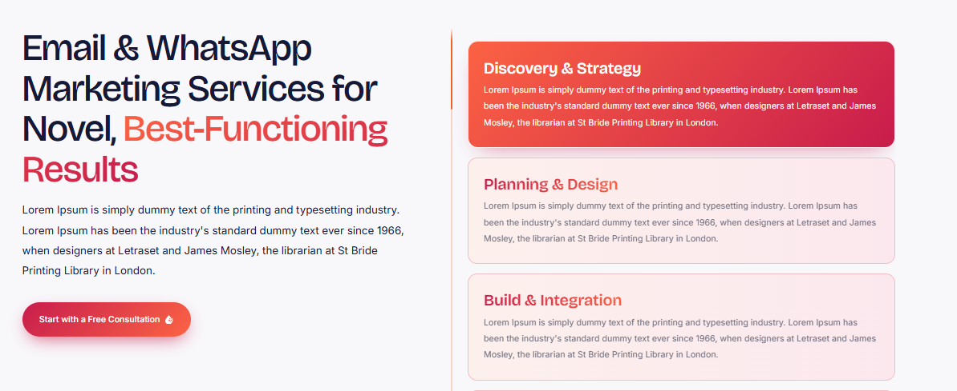

Why choose us?
Dynamic content and campaign strategies are used to make sure that messages are delivered to accomplish your business needs. Our uniqueness lies in our customization, audience awareness, and in-depth engagement, not in the generic messages we send. Our multichannel marketing strategies ensure that you can communicate consistently across all channels, building lasting customer loyalty, whether you're nurturing potential customers or reconnecting with existing ones.
1. Discovery & Goal Setting: We know what you're looking to achieve, who you are communicating with, and your business goals.
2. Audience Segmentation: We segment our eligible contact lists on customer interests, preferences and engagement.
3. Campaign Planning & Content Creation: Create your emails, promotions & content for WhatsApp campaigns that are engaging and effective for your audience.
We schedule and send campaigns using appropriate channels, according to relevant consent and messaging rules.
5. Performance Analysis & Optimization: We analyze the delivery, engagement, clicks and conversion to optimize future email and WhatsApp marketing campaigns.
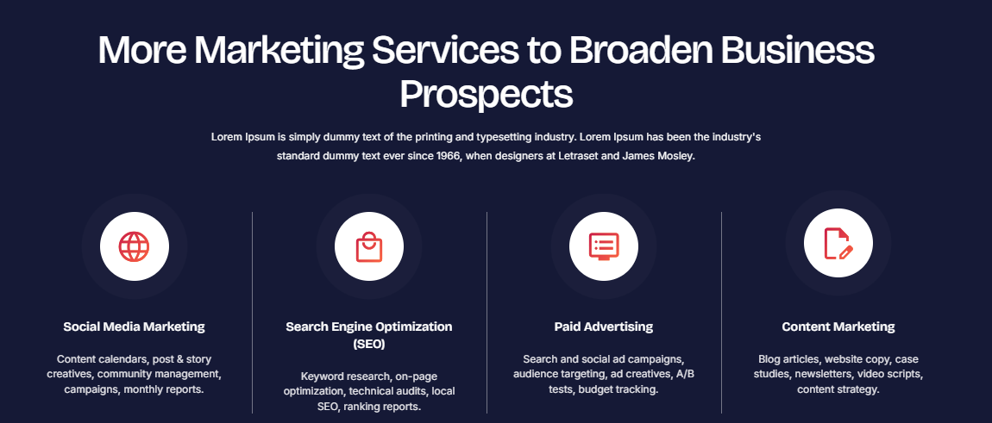

Broaden Your Businesses with Our Digital Marketing Services
Ink Pixel Studio is a digital marketing agency that provides custom-made solutions to assist businesses in becoming more visible and attracting a more targeted audience while fostering long-term customer connections.
- Search Engine Optimization (SEO)
Get your website optimized for search engines to boost its visibility, covering keyword research, on page optimization, technical optimization and content optimization.
- Paid Advertising
Connect with target audiences via relevant paid advertising like Google Ads and social media ads based on business goals, reach, frequency, and targets.
- Content Marketing
Engage customers with the right content marketing services, such as blogs, website content, social media and useful brand resources.
- Email & WhatsApp Marketing
Improve customer relations by engaging them with tailored email marketing and WhatsApp marketing messages, which convey updates and offers and cultivate leads.

SEO


SEO Services
Ink Pixel Studio has the ability to assist businesses in enhancing their online presence and driving targeted traffic to their website with the help of a well-considered approach to Search Engine Optimization (SEO). This involves keyword research, on-page optimization, technical optimization, content optimization, and link building strategies that will help enhance the performance of your website in search. We work on optimizing your website structure, user experience and content relevance to ensure search engines "understand" your business.
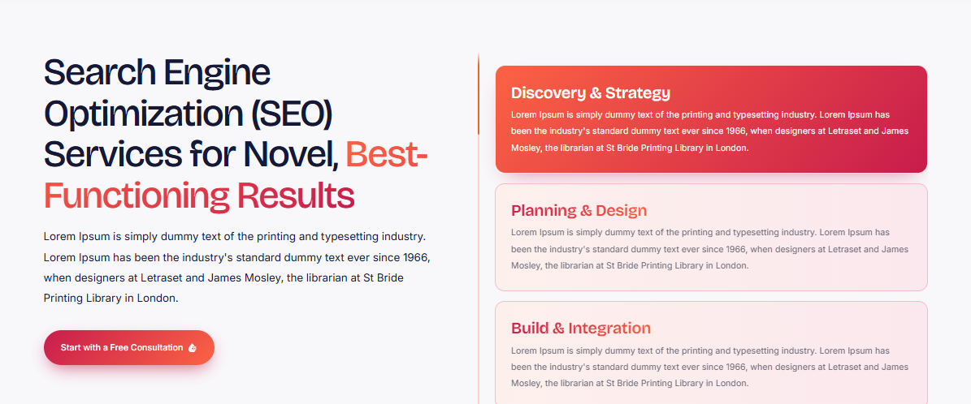

Why choose us?
Data-driven insights coupled with personalized SEO by industry, audience and business goals. We strive for sustainable, organic growth instead of quick fixes and unrealistic promises, and we have a personalized approach and open tracking of performance. Whether you're starting a new website or enhancing your current online presence, our SEO services are designed to help you gain search visibility, reach potential customers, and foster long-term digital success.
1. SEO Audit & Consultation: We check your website, existing ranking, technical state and company objectives.
2. Keyword Research & Competitor Analysis: This involves finding SEO keywords that are relevant to your business and examining your competitor's tactics to see if there's any room to compete.
3. On-Page & Technical Optimization: Optimizes page titles, headings, content, internal-links, site-structure and technical performance.
4. Content & Authority Building: We strengthen website content and pursue relevant, quality-focused link-building opportunities.
5. Monitoring & Reporting: We track rankings, organic traffic, and engagement, using performance insights to refine your ongoing SEO strategy.
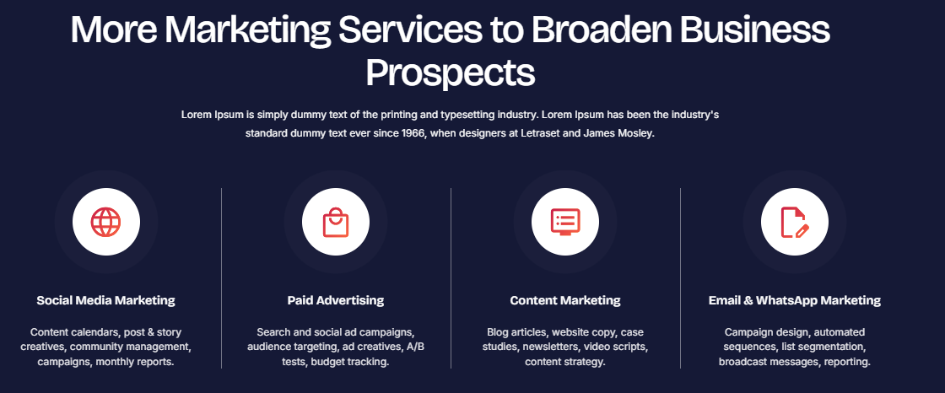

Broaden Your Businesses with Our Digital Marketing Services
Ink Pixel Studio is a digital marketing agency that provides custom-made solutions to assist businesses in becoming more visible and attracting a more targeted audience while fostering long-term customer connections.
- Search Engine Optimization (SEO)
Get your website optimized for search engines to boost its visibility, covering keyword research, on page optimization, technical optimization and content optimization.
- Paid Advertising
Connect with target audiences via relevant paid advertising like Google Ads and social media ads based on business goals, reach, frequency, and targets.
- Content Marketing
Engage customers with the right content marketing services, such as blogs, website content, social media and useful brand resources.
- Email & WhatsApp Marketing
Improve customer relations by engaging them with tailored email marketing and WhatsApp marketing messages, which convey updates and offers and cultivate leads.

Content Marketing


Content Marketing
Ink Pixel Studio's content marketing services are crafted to inform, engage, and inspire, ensuring that businesses are reaching their audience through strategic content. Whether it's blog posts, website articles, social media posts, email newsletters, or SEO-optimized articles, we produce content that is valuable and that has your voice and aligns with your business objectives. The content marketing strategy emphasizes the needs of the audience, appropriate keywords, and regular content, as it helps build brand recognition and contributes to organic growth.
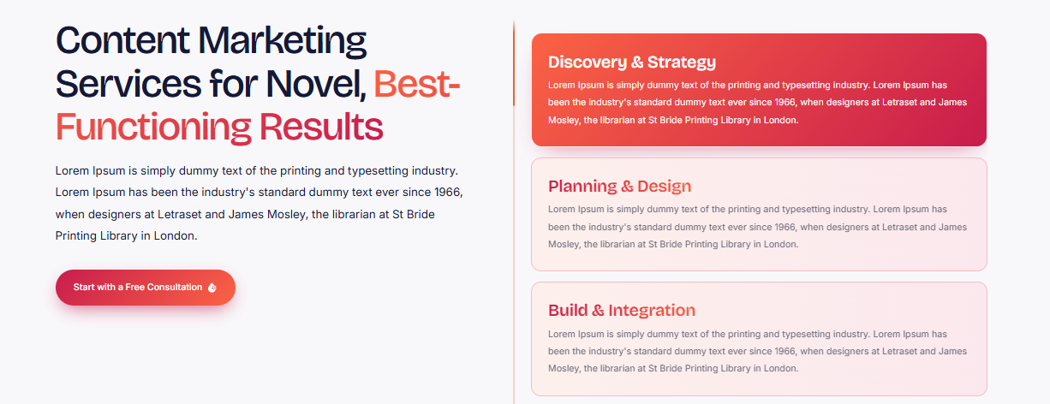

Why choose us?
We tell stories in a creative way and we plan accordingly based on research so you can be understood correctly. The difference that sets us apart is our personalized approach, attention to brand consistency, commitment to creating purposeful content, and not producing content just for the sake of filling a schedule. From creating brand awareness to developing a potential customer, we can help you get the right message to the right audience.
- Discovery & Goal Setting: We know your business goals, brand tone and audience.
- Research & Strategy: Conducting audience research, keyword analysis, and content opportunity research to create a content marketing strategy.
- Content Planning & Creation: We create compelling and SEO-optimized content such as blogs, website copy, and social media content.
- Publishing & Distribution: We arrange the content publishing and disseminate the approved content through appropriate digital media.
- Performance Review & Optimization: Review of engagement, traffic, etc. to optimize future content marketing campaigns.
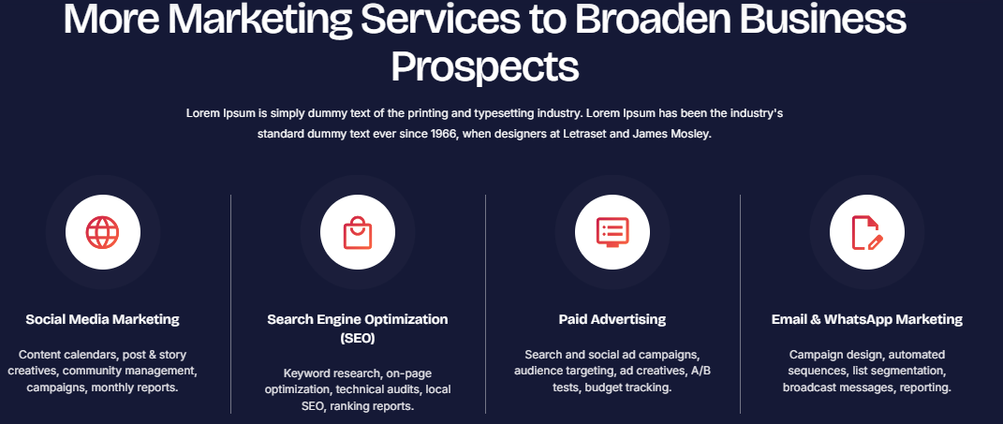

Broaden Your Businesses with Our Digital Marketing Services
Ink Pixel Studio is a digital marketing agency that provides custom-made solutions to assist businesses in becoming more visible and attracting a more targeted audience while fostering long-term customer connections.
- Search Engine Optimization (SEO)
Get your website optimized for search engines to boost its visibility, covering keyword research, on page optimization, technical optimization and content optimization.
- Paid Advertising
Connect with target audiences via relevant paid advertising like Google Ads and social media ads based on business goals, reach, frequency, and targets.
- Content Marketing
Engage customers with the right content marketing services, such as blogs, website content, social media and useful brand resources.
- Email & WhatsApp Marketing
Improve customer relations by engaging them with tailored email marketing and WhatsApp marketing messages, which convey updates and offers and cultivate leads.

Analytics & Growth Strategy


Analytics & Growth Strategy
Ink Pixel Studio's data-driven analytics and growth strategy services assist businesses in making intelligent decisions and fostering sustainable growth. We monitor the traffic, customer engagement, campaign effectiveness and conversion patterns to uncover areas for improvement. We use digital marketing data and analytics to guide our strategies, helping you to optimize marketing campaigns, enhance customer engagement and make informed decisions about resource allocation.
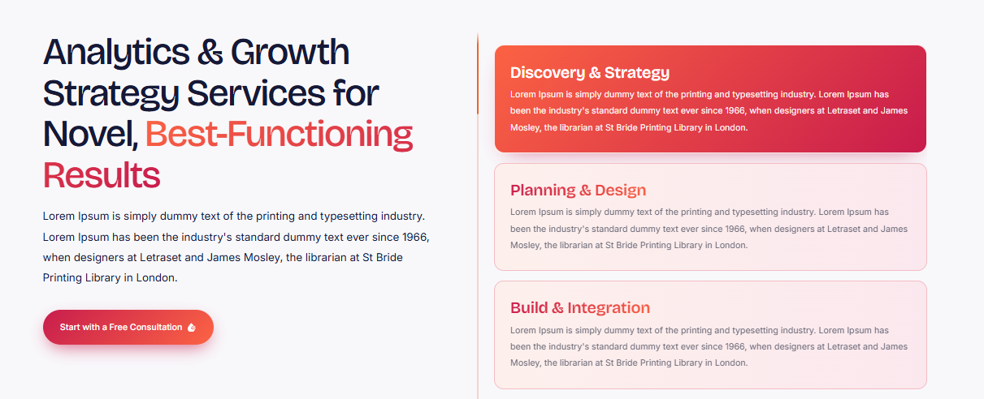

Why choose us?
We merge analytical thinking with practical solutions that assist you to achieve your business goals. What sets us apart is our customization, the fact that we focus on what matters most as far as performance indicators go, and the fact that we are not just giving you numbers, but actually help you to see them as measurable opportunities. From conversion optimization to marketing campaign optimization and from digital expansion, our data-driven growth solutions tell you what's working and what needs to be done next for sustained success.
1. Discovery & Goal Setting: We learn what your goals are for your business, and set specific and measurable goals.
2. Data Collection & Analysis: We examine website analytics, audience interactions and marketing campaign efficiency.
3. Opportunity Identification: Performance gap identification, barriers to conversion and potential growth opportunities.
4. Strategy Development: We develop a clear action plan with recommendations, prioritized to achieve your growth objectives.
5. Performance Tracking & Optimization: Tracking key performance indicators (KPIs), analyzing performance outcomes, and adjusting strategies to facilitate ongoing enhancements.
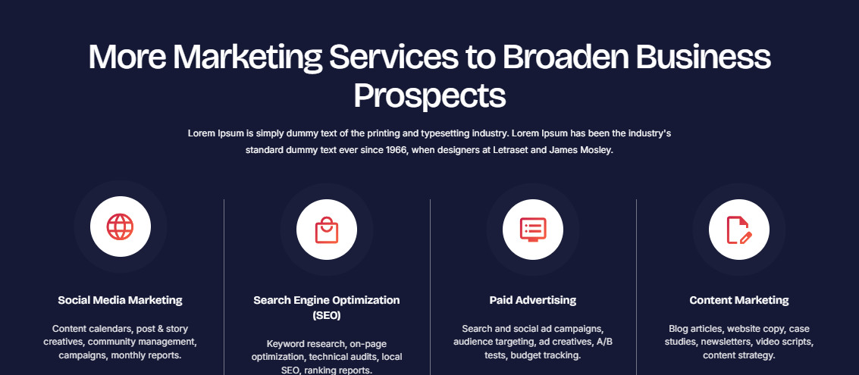

Broaden Your Businesses with Our Digital Marketing Services
Ink Pixel Studio is a digital marketing agency that provides custom-made solutions to assist businesses in becoming more visible and attracting a more targeted audience while fostering long-term customer connections.
- Search Engine Optimization (SEO)
Get your website optimized for search engines to boost its visibility, covering keyword research, on page optimization, technical optimization and content optimization.
- Paid Advertising
Connect with target audiences via relevant paid advertising like Google Ads and social media ads based on business goals, reach, frequency, and targets.
- Content Marketing
Engage customers with the right content marketing services, such as blogs, website content, social media and useful brand resources.
- Email & WhatsApp Marketing
Improve customer relations by engaging them with tailored email marketing and WhatsApp marketing messages, which convey updates and offers and cultivate leads.

Software
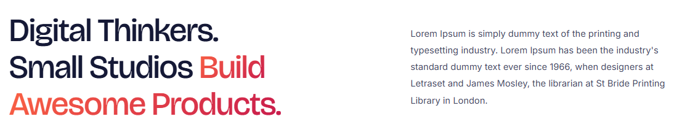

Why choose our Software Services?
Our technical expertise, creative problem solving, and client-centered thinking process enable us to provide software that solves real business problems. We are unique because we understand your workflows before suggesting a solution and we have a point of view on everything we include to make sure it has a clear purpose. We build the software solutions that are scalable, easy to use and will integrate well with your business as it grows. Whether it's custom software development, business automation, workflow management systems or integrated applications, we create solutions tailored to your needs.

Custom Software Development


Custom Software Development
Ink Pixel Studio specialize in delivering bespoke custom software solutions that enable businesses to streamline their operations, address unique challenges, and boost productivity. We specialize in custom software development, offering a range of solutions from business management tools and workflow automation to specialized applications, tailored to your specific needs. Focus is on functionality, security, scalability and seamless integration, ensuring that your software supports your business objectives.
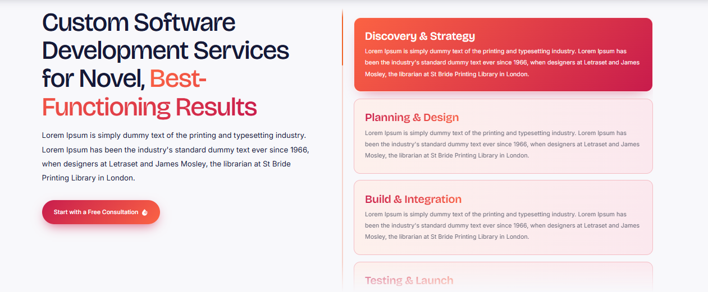

Why choose us?
We spend time getting to know your processes before we introduce technologies or features to you, so that the solution we provide meets your actual operational requirements. We are different because we work with you to develop your software in a personal way, with attention to detail, and with commitment to helping you achieve the goals you are looking for; we don't try to make your business fit into a system that doesn't fit. Our custom-made business software solutions enable you to work smartly and future-proof your business, whether you're automating repetitive tasks or building a new digital product.
1. Discovery & Requirement Analysis: We grasp your business problem, business processes, goals, and what software capabilities are crucial for you.
2. Planning & Architecture: We outline software structure, technology stack, integrations and development trajectory.
Design & Development: We develop your very own software solution using user friendly designs and features that suit your needs.
4. Testing & Quality Assurance: Testing features, performance, security and compatibility to detect and resolve issues.
5. Deployment & Ongoing Support: We deploy the approved software and guide and maintain the software as agreed to ensure continued performance.

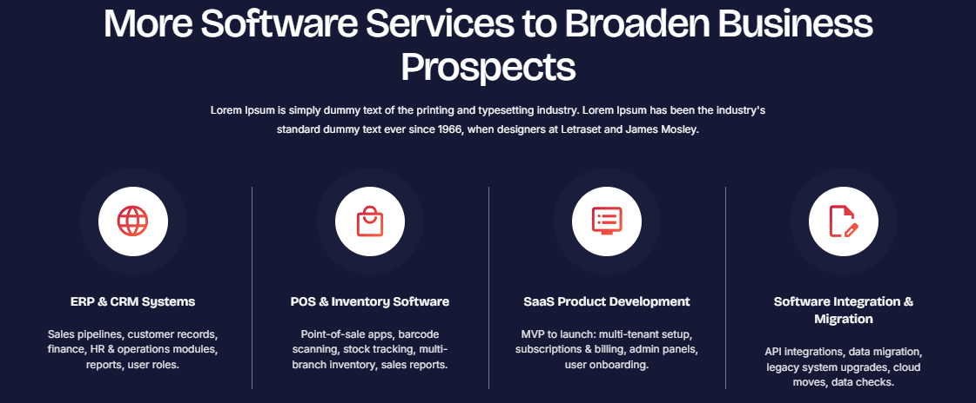

Broaden Your Businesses with Our Different Software Services
We at Ink Pixel Studio create customized programs that enhance business efficiency, productivity and growth. We're here to help you create functional, scalable systems that work for your processes and goals.
- ERP & CRM Systems
We create bespoke ERP and CRM solutions to streamline processes between departments, centralize business operations and manage customer relationships.
- POS & Inventory Software
The POS and inventory management software streamlines business operations, enabling seamless transactions, inventory tracking, and sales management through a digital system.
- SaaS Product Development
We develop scalable Software as a Service (SaaS) application that enable companies to offer digital products and services on cloud-based, easily accessible platforms.
- Software Integration & Migration
Our software integration and migration services ensure seamless data transfer, link existing systems and support businesses to new platforms and platforms with minimal disruption.

POS & Inventory Software


POS & Inventory Software
Ink Pixel Studio offers businesses custom POS and inventory software solutions to streamline their sales and inventory management. We integrate all these functionalities into a single solution: point of sale (POS) systems, inventory management software, sales tracking, and stock monitoring, which enables businesses to streamline their daily transactions. Whether you're looking for retail store solutions or restaurant solutions, or are a growing business, we create systems that work for you operationally.
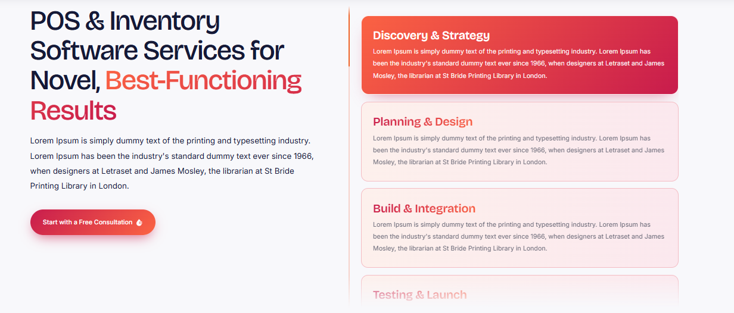

Why choose us?
Our emphasis is on developing practical, user-friendly software that enhances accuracy, efficiency and decision making. Whether you need faster checkout, better stock visibility, or centralized sales management, our custom POS and inventory solutions help you maintain control as your business grows.
1. Requirement Analysis: We identify your sales workflows, inventory needs, business goals, and essential system features.
2. System Planning: We map out POS functionality, stock tracking, reporting, user roles, and required integrations.
3. Software Development: We build your custom POS and inventory management system with features tailored to your operations.
4. Testing & Validation: We test transaction processing, stock updates, reporting accuracy, and system performance.
5. Deployment & Support: We implement the approved system, guide your team through its use, and provide agreed-upon technical support.

Broaden Your Businesses with Our Different Software Services
We at Ink Pixel Studio create customized programs that enhance business efficiency, productivity and growth. We're here to help you create functional, scalable systems that work for your processes and goals.
- ERP & CRM Systems
We create bespoke ERP and CRM solutions to streamline processes between departments, centralize business operations and manage customer relationships.
- POS & Inventory Software
The POS and inventory management software streamlines business operations, enabling seamless transactions, inventory tracking, and sales management through a digital system.
- SaaS Product Development
We develop scalable Software as a Service (SaaS) application that enable companies to offer digital products and services on cloud-based, easily accessible platforms.
- Software Integration & Migration
Our software integration and migration services ensure seamless data transfer, link existing systems and support businesses to new platforms and platforms with minimal disruption.

Software Integration & Migration Services


Software Integration & Migration Services
Ink Pixel Studio offers businesses dependable software integration and migration solutions, enabling them to link their digital tools and move between different platforms. Our solutions allow different applications, databases and business systems to communicate with each other to increase data flow and operational efficiency. Whether it's integration with API or connecting with third-party applications, moving your databases or upgrading your platforms, we handle the technical aspects of connecting your systems. 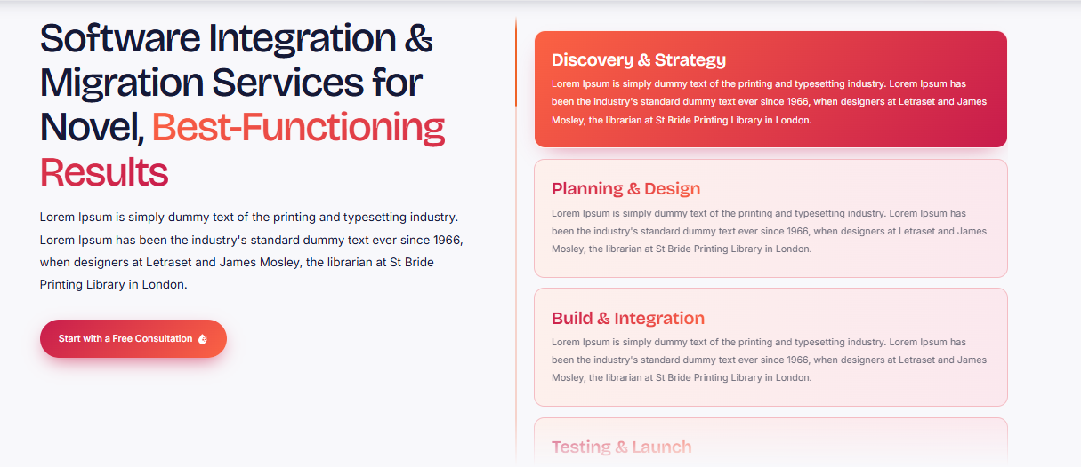

Why choose us?
We strive to ensure the accuracy of data, compatibility of the system and minimal disruption to operations throughout. The difference that makes us unique is our approach to fit your current infrastructure and workflows into our recommendations for the most appropriate integration or migration solution. From outdated software to integrating multiple applications, our custom software integration solutions can help you build a more integrated, efficient and scalable digital environment.
1. System Assessment: We examine your current software and hardware, data sources, and business needs.
2. Strategy & Planning: We identify the software migration approach, the integration scope and requirements, the migration timeline, and how to protect the data.
3. Integration & Data Migration: We integrate compatible systems, set up necessary APIs and migrate data as per the agreed plan.
4. Testing & Validation: We test & validate data, system, functionality and performance to detect any problems.
5. Deployment & Support: We deploy the integrated or migrated solution, keep it running and offer agreed technical support.
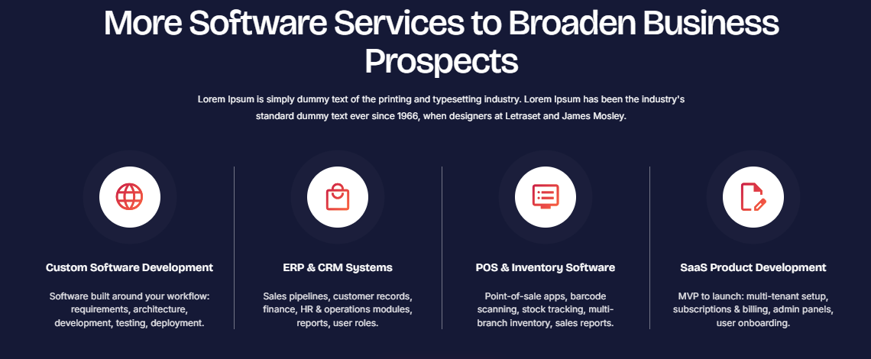

Broaden Your Businesses with Our Different Software Services
We at Ink Pixel Studio create customized programs that enhance business efficiency, productivity and growth. We're here to help you create functional, scalable systems that work for your processes and goals.
- ERP & CRM Systems
We create bespoke ERP and CRM solutions to streamline processes between departments, centralize business operations and manage customer relationships.
- POS & Inventory Software
The POS and inventory management software streamlines business operations, enabling seamless transactions, inventory tracking, and sales management through a digital system.
- SaaS Product Development
We develop scalable Software as a Service (SaaS) application that enable companies to offer digital products and services on cloud-based, easily accessible platforms.
- Software Integration & Migration
Our software integration and migration services ensure seamless data transfer, link existing systems and support businesses to new platforms and platforms with minimal disruption.

ERP & CRM Systems Services


ERP & CRM Systems Services
At Ink Pixel Studio, we can assist companies in streamlining their operations and fostering customer connections by developing ERP and CRM systems that are customized to their specific requirements. The ERP solutions provide us the centralization and organization of important business functions like inventory, finance, workflow management etc. and the CRM systems helps us to keep the customer information organized, track the leads and enhance the sales processes. We create bespoke ERP and CRM solutions to suit your business needs, to streamline processes and improve access to information.
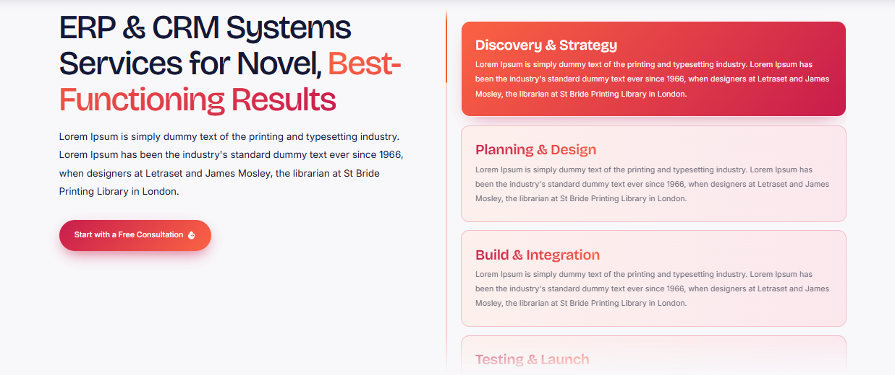

Why choose us?
We are about the practical functionality, seamless integration, and solutions based around your operational needs. We're different because we know your processes and won't recommend features that could be more complicated than they need to be. From simplifying internal processes to enhancing customer management, our scalable ERP and CRM solutions empower businesses to make informed decisions and foster sustainable growth.
1. Evaluation: We evaluate your workflows, customer management requirements, challenges and goals.
2. System Planning: System Architecture, required modules, user roles and integration needs.
3. Custom Development: We customize ERP or CRM according to your business processes.
4. Testing & Optimization: Functionality, data accuracy, security and system performance are tested to resolve issues.
5. Deployment & Support: We deploy the solution, guide your team in the features of the solution, and offer agreed technical support as needed.
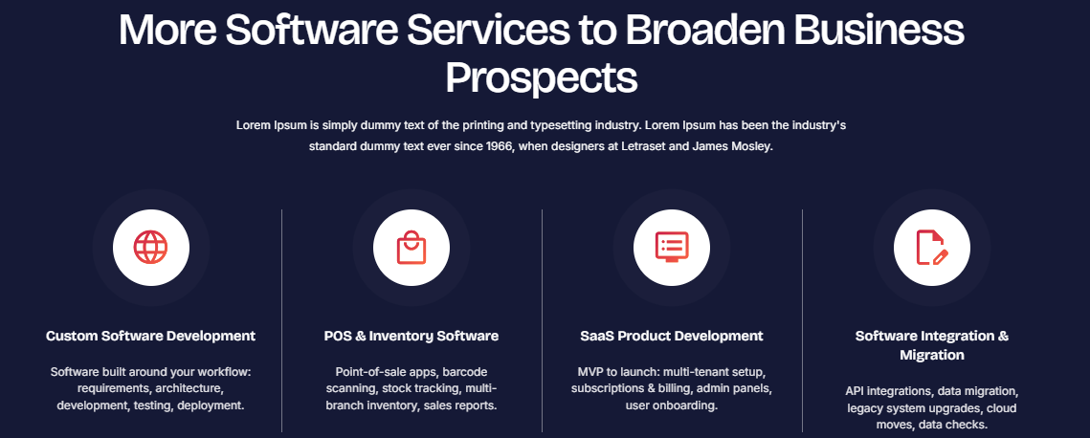

Broaden Your Businesses with Our Different Software Services
We at Ink Pixel Studio create customized programs that enhance business efficiency, productivity and growth. We're here to help you create functional, scalable systems that work for your processes and goals.
- ERP & CRM Systems
We create bespoke ERP and CRM solutions to streamline processes between departments, centralize business operations and manage customer relationships.
- POS & Inventory Software
The POS and inventory management software streamlines business operations, enabling seamless transactions, inventory tracking, and sales management through a digital system.
- SaaS Product Development
We develop scalable Software as a Service (SaaS) application that enable companies to offer digital products and services on cloud-based, easily accessible platforms.
- Software Integration & Migration
Our software integration and migration services ensure seamless data transfer, link existing systems and support businesses to new platforms and platforms with minimal disruption.

SaaS Product Development


SaaS Product Development
In Ink Pixel Studio, we transform innovative ideas into scalable digital products with customizable SaaS product development services. We develop Software as a Service (SaaS) application that enable businesses to offer software via cloud-based platforms, making solutions accessible throughout gadgets. Our custom SaaS development services are designed with usability, security, performance, and scalability in mind, from subscription-based platforms to customer portals, and even business management tools.
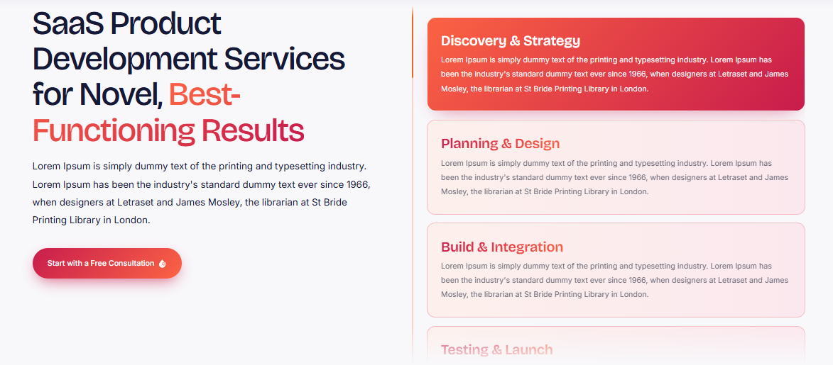

Why choose us?
Technical planning and user product vision are carefully weighed to create solutions which meet actual user needs. Our unique approach, attention to functionality and our focus on creating flexible products that can grow with your business are what sets us apart. From introducing a new software solution to upgrading an existing platform, we can support your vision and help you see it through to a secure, long-term digital solution.
1. Discovery & Product Planning: We get to know your idea, your target users, your business model and what you need for your product.
2. Architecture & Prototyping: We design the SaaS application architecture, user journeys, database design and technical specifications.
3. Design & Development: We develop your personalized SaaS platform with user-friendly interfaces, essential functions, and suitable cloud solutions.
4. Testing & Quality Assurance: Testing functionality, security, performance and compatibility in order to find and fix problems.
5. Deployment & Ongoing Improvement: We introduce your product, monitor its performance and offer agreed support assisting it to grow with user needs.
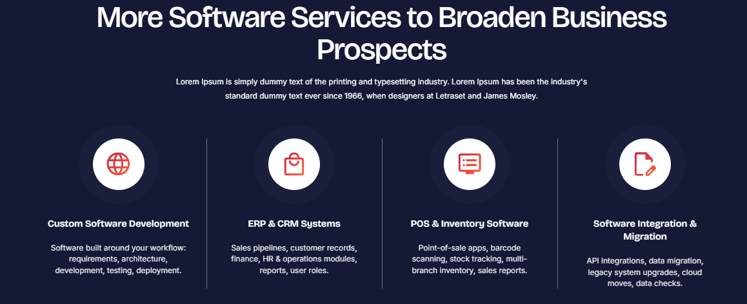

Broaden Your Businesses with Our Different Software Services
We at Ink Pixel Studio create customized programs that enhance business efficiency, productivity and growth. We're here to help you create functional, scalable systems that work for your processes and goals.
- ERP & CRM Systems
We create bespoke ERP and CRM solutions to streamline processes between departments, centralize business operations and manage customer relationships.
- POS & Inventory Software
The POS and inventory management software streamlines business operations, enabling seamless transactions, inventory tracking, and sales management through a digital system.
- SaaS Product Development
We develop scalable Software as a Service (SaaS) application that enable companies to offer digital products and services on cloud-based, easily accessible platforms.
- Software Integration & Migration
Our software integration and migration services ensure seamless data transfer, link existing systems and support businesses to new platforms and platforms with minimal disruption.

QA, Testing & Support Services


QA, Testing & Support Services
Comprehensive Quality Assurance (QA), software testing, and technical support services are the means by which businesses can keep their digital products reliable with the help of Ink Pixel Studio. We aim to detect defects, enhance functionality and validate your software before and after release. Whether it's functional testing and performance testing, compatibility checks, or tracking bugs and providing continuous support, we help minimize technical problems and enhance the user experience.
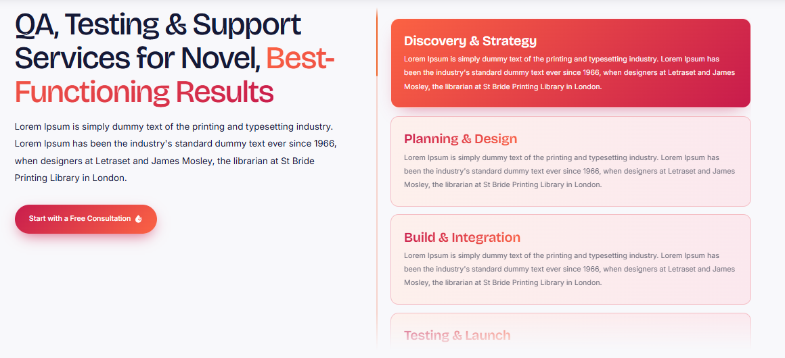

Why choose us?
We use a systematic testing and a problem-solving approach to provide stable and reliable software. The difference with us is that we pay attention to detail, we have customized testing strategies and we are not only focusing on fixing what we see, we are focusing on preventing it from happening again. We can prepare a new application for launch or maintain an existing platform, no matter what the situation, our software quality assurance services will help ensure the functionality, reliability and support of your business.
1. Requirement Analysis: We are analyzing your software needs, desired functionality, and quality requirements.
2. Test Planning: We create a software testing plan with structure in order to cover important features, devices, flow of work and potential risks.
3. Testing & Bug Identification: Function testing, usability testing, compatibility testing & performance testing are performed on relevant tests to identify defects.
4. Bug Fixing & Retesting: We log bugs, assist their fixing and retest impacted features to ensure enhancements.
5. Deployment & Ongoing Support: We check software readiness, and offer agreed technical support and maintenance to help maintain your software's reliability.

Broaden Your Businesses with Our Different Software Services
We at Ink Pixel Studio create customized programs that enhance business efficiency, productivity and growth. We're here to help you create functional, scalable systems that work for your processes and goals.
- ERP & CRM Systems
We create bespoke ERP and CRM solutions to streamline processes between departments, centralize business operations and manage customer relationships.
- POS & Inventory Software
The POS and inventory management software streamlines business operations, enabling seamless transactions, inventory tracking, and sales management through a digital system.
- SaaS Product Development
We develop scalable Software as a Service (SaaS) application that enable companies to offer digital products and services on cloud-based, easily accessible platforms.
- Software Integration & Migration
Our software integration and migration services ensure seamless data transfer, link existing systems and support businesses to new platforms and platforms with minimal disruption.

Applications
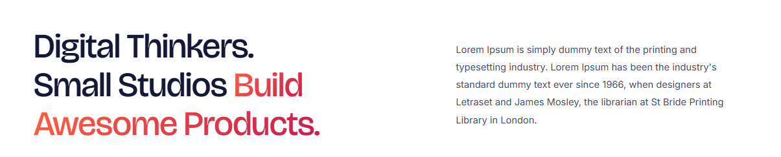

Why choose our Applications Services?
Our technical skills, creative thinking and client-oriented approach enable us to provide the applications to address real business challenges. Unlike most, we are interested in knowing what you need before we start building, and make sure every part of a website has a function. Our development approach prioritizes scalability, performance, security, and user-friendliness, ensuring that the applications we create can grow with your business and are well-positioned for future digital success.

Web Applications & PWAs Services


Web Applications & PWAs Services
Ink Pixel Studio creates scalable web app development and Progressive Web Apps (PWAs) to assist businesses in providing a seamless digital experience across devices. We build web apps, dashboards, interactive platforms, customer portals and business tools tailored to your business needs. Progressive Web App development involves building applications that perform as apps, including offline functionality where supported and install ability, with responsive applications working in Web browsers.
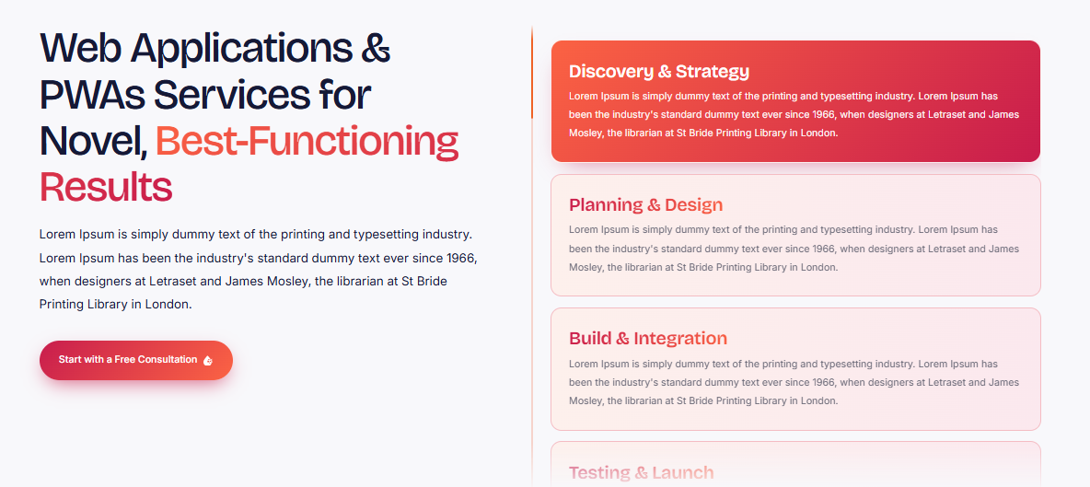

Why choose us?
Our technical skill is blended with a user-centric approach to create solutions that are dependable, accessible, and scalable. Our unique selling point is our approach of customizing to the client's needs, performance and our commitment to actually solving problems, not adding unnecessary features. Our custom web applications can optimize internal operations or enhance customer access, boosting your business to meet the evolving demands of the digital age.
1. Discovery & Requirement Analysis: We define your business objectives, user needs, must have features, and technical needs.
2. Planning & Architecture: We create user journeys, application architecture, database needs, and appropriate technologies.
3. UI/UX Design & Development: We build straightforward interfaces and develop your web application or PWA that is responsive.
Testing & Optimization: Testing for usability, browser compatibility, performance, security and supported PWA features.
5. Deployment & Support: We upload the agreed application and deliver agreed maintenance to ensure that the application is reliable and can be enhanced in the future.
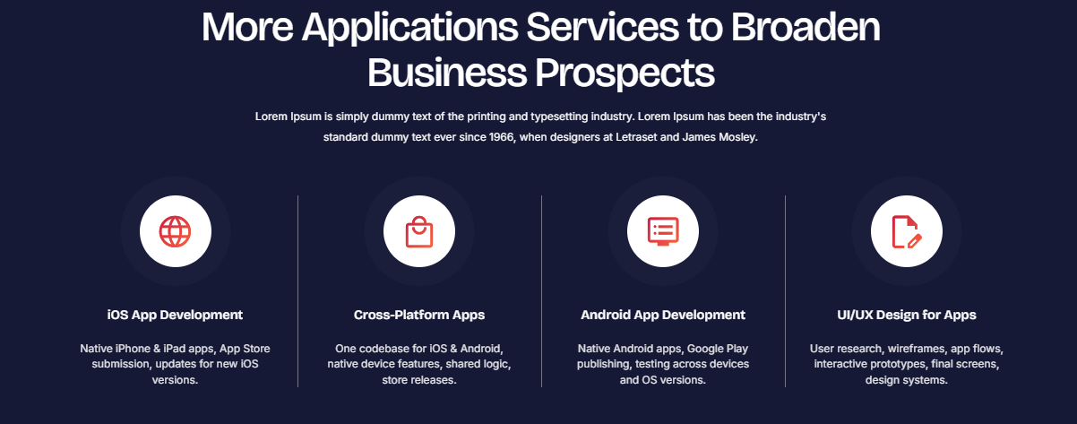

Broaden Your Businesses with Our Different Applications Services
Our technical skills, creative thinking and client-oriented approach enable us to provide the applications to address real business challenges.
- iOS App Development
We create robust and efficient iOS apps optimized for iPhone and iPad, featuring intuitive design, dependable performance, and integration with the Apple ecosystem.
- Cross-Platform Apps
We're experts in app development across multiple platforms, offering you apps that work on both iOS and Android with a shared codebase as much as possible.
- Android App Development
We create custom Android applications that are optimized for performance, usability and user-friendliness on Android devices that have the required compatibility.
- UI/UX Design for Apps
Our UI/UX design for mobile application is focused on intuitive navigation, clear layouts and user journeys to make the applications easier to use.

Cross-Platform App Development Services


Cross-Platform App Development Services
Ink Pixel Studio empowers businesses to connect with larger audiences by creating custom-made, cross-platform apps. We develop applications that support both iOS and Android devices, providing an identical functionality and user experience and eliminating the need to write and manage two separate codebases. Our tailored cross-platform mobile applications blend user-friendly design with robust performance and scalable architecture, all bolstered by the appropriate technologies and frameworks.
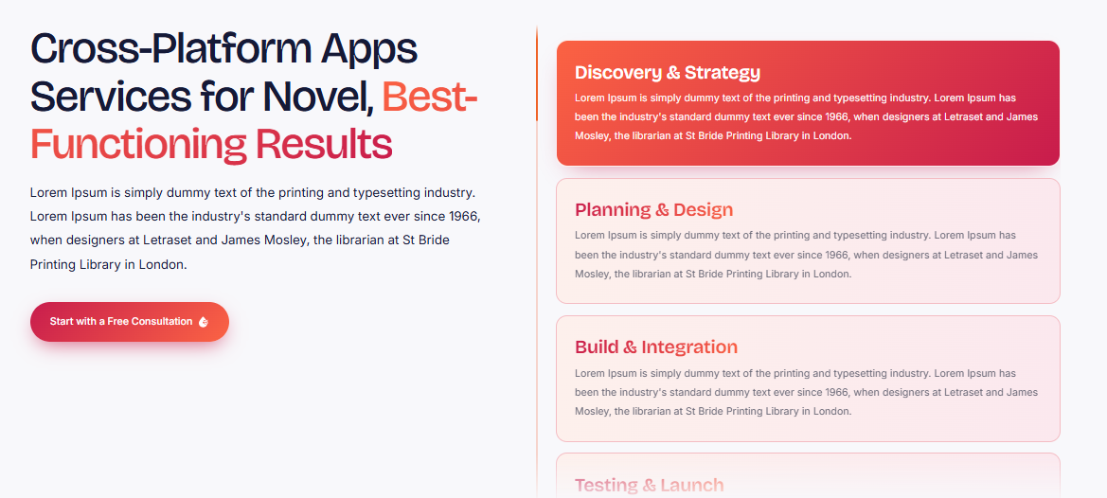

Why choose us?
All applications are aligned with business goals, target audience and technical requirements. Our unique approach to application development is based on personalized development, practical functionality and a desire to create applications that perform well whilst being developed efficiently. With our cross-platform app development solutions, you can create a flexible foundation for your digital product, ready for future growth, whether you're launching a new app or expanding an existing service to mobile users.
1. Discovery & Planning: We uncover your business objectives, users, features, and platform needs.
2. UI/UX Design: We develop user friendly UI and user journey for both iOS and Android devices.
3. App Development: We create your cross-platform mobile application in an appropriate framework and using reusable code if applicable.
4. Testing & Optimization: Testing functionality, responsiveness, device compatibility, security, and performance on platforms supported.
5. Deployment & Support: We deploy your app and agree to maintenance & updates for continued performance.
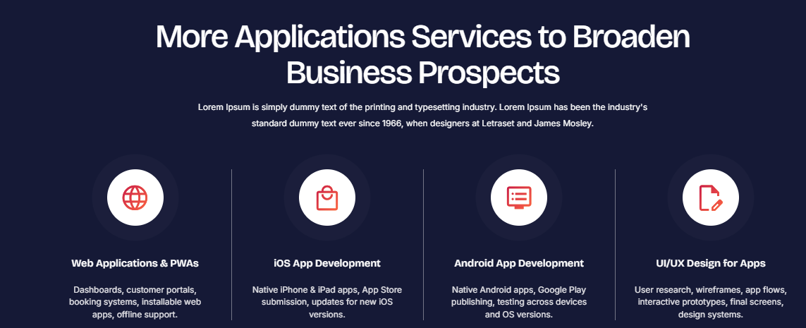

Broaden Your Businesses with Our Different Applications Services
Our technical skills, creative thinking and client-oriented approach enable us to provide the applications to address real business challenges.
- iOS App Development
We create robust and efficient iOS apps optimized for iPhone and iPad, featuring intuitive design, dependable performance, and integration with the Apple ecosystem.
- Cross-Platform Apps
We're experts in app development across multiple platforms, offering you apps that work on both iOS and Android with a shared codebase as much as possible.
- Android App Development
We create custom Android applications that are optimized for performance, usability and user-friendliness on Android devices that have the required compatibility.
- UI/UX Design for Apps
Our UI/UX design for mobile application is focused on intuitive navigation, clear layouts and user journeys to make the applications easier to use.

Broaden Your Businesses with Our Different Applications Services

UI/UX Design for Apps Services


UI/UX Design for Apps Services
We deliver personalized UI/UX design solutions for mobile applications at Ink Pixel Studio that provide intuitive and engaging mobile experiences. We integrate user interface (UI) design and user experience (UX) design to create applications that are both visually pleasing and easy to navigate and meet the expectations of the user. We design every aspect of your website, from wireframes to interactive prototypes, from interface design to navigation flows, all with usability in mind.
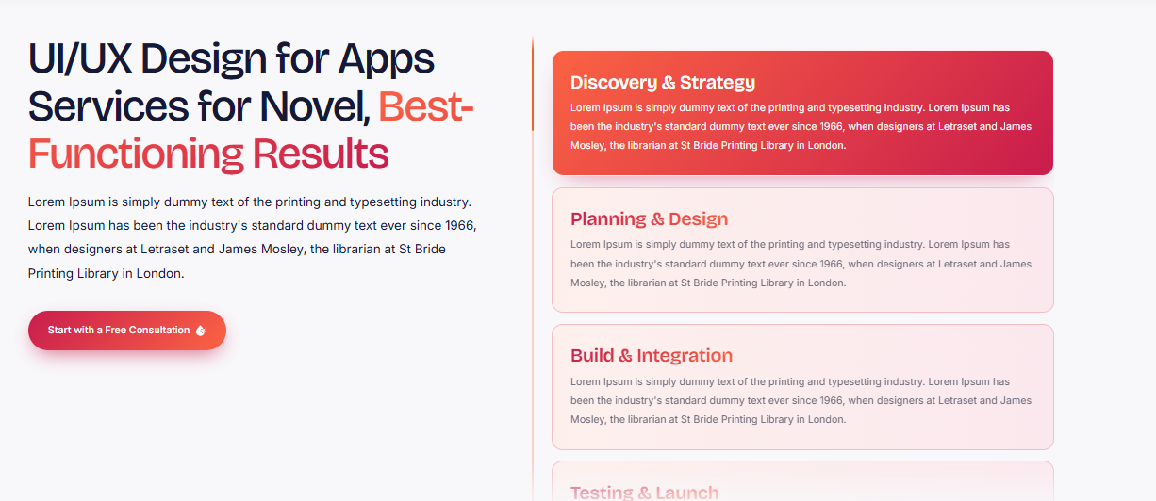

Why choose us?
Using creative thinking and user-centered design, we make your app look good and intuitive to use. We are unique because we put the needs of the users first, observe their interactions with our websites and simplify the process of interacting with our site without making it more complicated. Our mobile app UI/UX design services streamline and enhance your mobile experience, ensuring consistency across all devices for engagement, accessibility, and business goals.
1. Discovery & User Research: We know your business objectives, your target users, their needs and what your application needs to achieve.
2. Information Design: We design pages and elements to display information in a logical and easily understood sequence.
3. Wireframing & Prototyping: App wireframing and interactive prototyping are provided for visualizing layouts and essential interactions.
4. Visual Interface Design: We create sleek mobile app interfaces with appropriate typography, colors, icons and other visual factors.
5. Usability Testing & Refinement: Test the design, collect input, and make design improvements and interactivity changes prior to developer handoff.

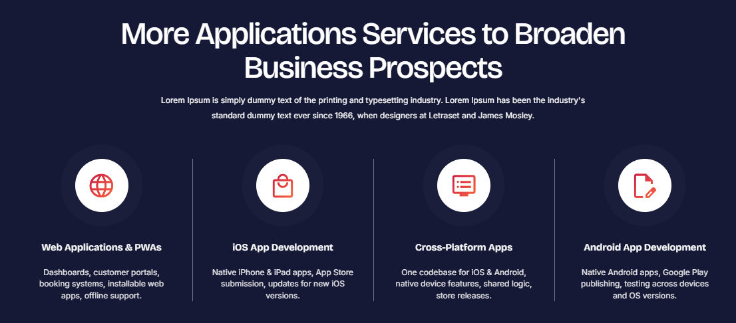

Broaden Your Businesses with Our Different Applications Services
Our technical skills, creative thinking and client-oriented approach enable us to provide the applications to address real business challenges.
- iOS App Development
We create robust and efficient iOS apps optimized for iPhone and iPad, featuring intuitive design, dependable performance, and integration with the Apple ecosystem.
- Cross-Platform Apps
We're experts in app development across multiple platforms, offering you apps that work on both iOS and Android with a shared codebase as much as possible.
- Android App Development
We create custom Android applications that are optimized for performance, usability and user-friendliness on Android devices that have the required compatibility.
- UI/UX Design for Apps
Our UI/UX design for mobile application is focused on intuitive navigation, clear layouts and user journeys to make the applications easier to use.

iOS App Development Services


iOS App Development Services
Ink Pixel Studio is a company that brings innovative iOS app development services to life, catering to each customer's unique objectives and requirements with a customized approach. We develop bespoke iPhone and iPad apps that integrate an easy-to-use interface, adaptable functionality, and a smooth user experience when operating on compatible Apple devices. Whether you're looking to develop a business application or a feature-rich mobile product, our custom iOS app development solutions are tailored to meet your business objectives and audience requirements.
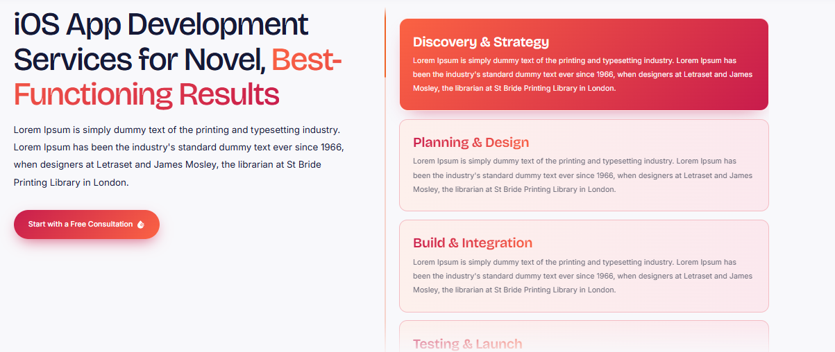

Why choose us?
We focus on both technical and user-centered design to develop functional, interactive, and scalable applications. The key thing which makes us different from others is our customization approach, attention to detail and focusing on understanding your needs and picking features and technologies as per your needs. From a new app to growing digital services, we can help bring your ideas to life and develop a functional iOS application that's designed to help your business thrive.
1. Discovery & Planning: We identify your business objectives, target audience, app requirements, and essential features.
2. UI/UX Design: We create intuitive iOS app interfaces and user journeys aligned with Apple's platform conventions.
3. App Development: We build your application using suitable iOS technologies, implementing the approved features and functionality.
4. Testing & Quality Assurance: We test usability, performance, security, and compatibility across supported Apple devices.
5. Deployment & Support: We prepare your app for App Store submission, assist with the release process, and provide agreed-upon maintenance and updates.
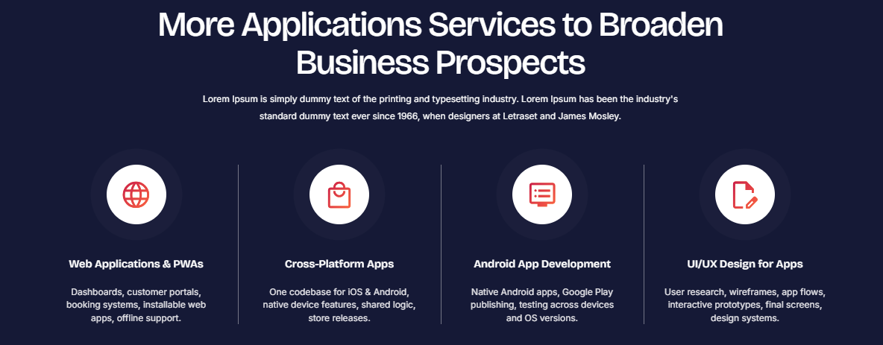

Broaden Your Businesses with Our Different Applications Services
Our technical skills, creative thinking and client-oriented approach enable us to provide the applications to address real business challenges.
- iOS App Development
We create robust and efficient iOS apps optimized for iPhone and iPad, featuring intuitive design, dependable performance, and integration with the Apple ecosystem.
- Cross-Platform Apps
We're experts in app development across multiple platforms, offering you apps that work on both iOS and Android with a shared codebase as much as possible.
- Android App Development
We create custom Android applications that are optimized for performance, usability and user-friendliness on Android devices that have the required compatibility.
- UI/UX Design for Apps
Our UI/UX design for mobile application is focused on intuitive navigation, clear layouts and user journeys to make the applications easier to use.

Android App Development Services


Android App Development Services
Ink Pixel Studio offers cutting-edge Android application development solutions that are customized to your business objectives and target market. Our team creates personalized Android mobile apps that offer intuitive design, performance and functionality on compatible devices. Whether it's a business app, e-commerce platform, customer portal, or on-demand solution, our custom Android app development services ensure your concept becomes a captivating digital experience.
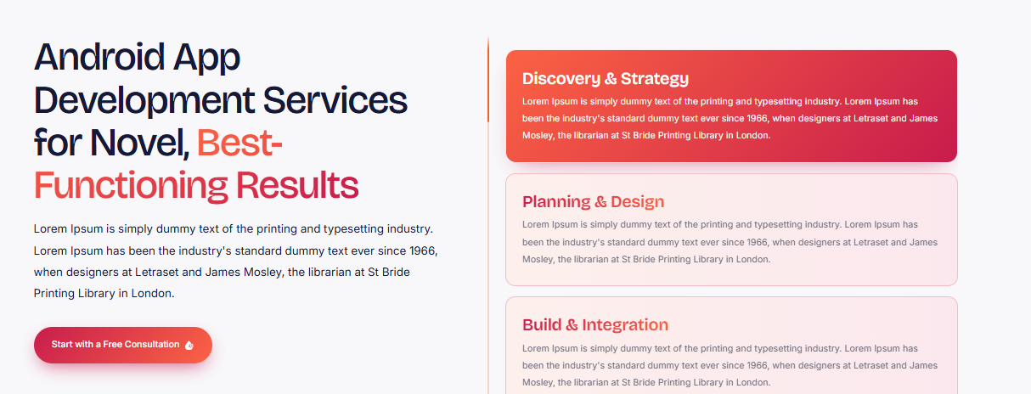

Why choose us?
We work to grasp your needs and define your users' needs and then create applications that meet your business goals. The difference that makes us different is our personalized approach, our attention to detail and our dedication to making scalable solutions, not one size fits all designs. From building a first-time app to making improvements to an existing one, we can help you create an app that is easily accessible, able to function efficiently, and is scalable for future growth.
1. Discovery & Planning: We know your business objectives, target audience, app criteria, and key features.
2. UI/UX Design: We build intuitive interfaces of Android applications, which ensures ease of navigation and make users enjoy using it.
3. App Development: Custom Android App that has the necessary features and functions.
4. Testing & Quality Assurance: We test on the supported Android devices for usability, performance, security and compatibility.
5. Launch & Ongoing Support: We submit your app to the Google Play store and agree to offer maintenance, updates and technical support.

Broaden Your Businesses with Our Different Applications Services
Our technical skills, creative thinking and client-oriented approach enable us to provide the applications to address real business challenges.
- iOS App Development
We create robust and efficient iOS apps optimized for iPhone and iPad, featuring intuitive design, dependable performance, and integration with the Apple ecosystem.
- Cross-Platform Apps
We're experts in app development across multiple platforms, offering you apps that work on both iOS and Android with a shared codebase as much as possible.
- Android App Development
We create custom Android applications that are optimized for performance, usability and user-friendliness on Android devices that have the required compatibility.
- UI/UX Design for Apps
Our UI/UX design for mobile application is focused on intuitive navigation, clear layouts and user journeys to make the applications easier to use.

App Maintenance & Scaling Services


App Maintenance & Scaling Services
Businesses can rely on Ink Pixel Studio for their application growth, security, and stability with our customizable app maintenance and scaling solutions. You can expect continuous maintenance of your app for bugs, performance, security and enhancements by our team. Our app scaling solutions can handle growing users, data growth, and changing business requirements without impacting the user experience as your business expands.
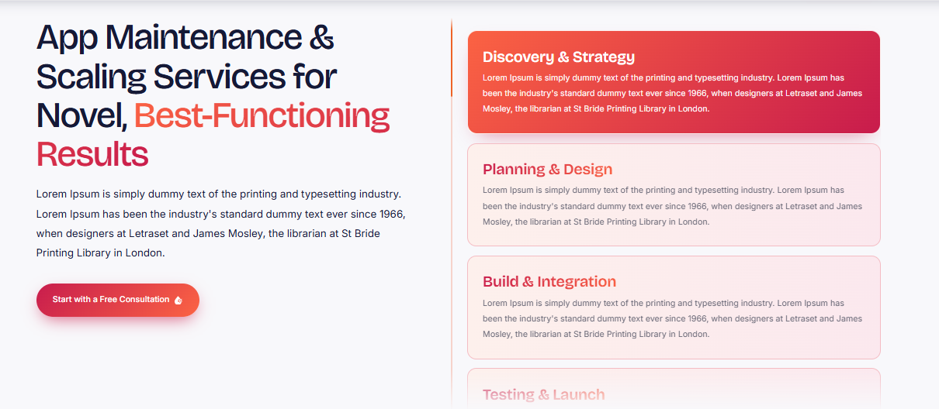

Why choose us?
Our attention is given to proactive enhancements, assurance and solutions that work in line with your business vision. We have a personalized approach, a high level of detail and a commitment to solving potential problems before they impact your users, all of which sets us apart. From periodic updates to enhanced functionality, our application support and maintenance services ensure your application can meet evolving needs, optimize performance, and lay the groundwork for long-term digital success.
1. App Audit & Assessment: We check your application's overall performance, capabilities, security and technical needs.
2. Issue Identification: We identify bugs, compatibility concerns, performance bottlenecks, and areas that need improvement.
3. Maintenance & Updates: We fix bugs, add security patches, apply software updates and implement required feature enhancements.
4. Performance Optimization & Scaling: Improve application performance and implement app scalability for increasing users, traffic and data.
5. Monitoring & Ongoing Support: All application performance is monitored, new problems are identified and solutions are developed as your business grows.

Broaden Your Businesses with Our Different Applications Services
Our technical skills, creative thinking and client-oriented approach enable us to provide the applications to address real business challenges.
- iOS App Development
We create robust and efficient iOS apps optimized for iPhone and iPad, featuring intuitive design, dependable performance, and integration with the Apple ecosystem.
- Cross-Platform Apps
We're experts in app development across multiple platforms, offering you apps that work on both iOS and Android with a shared codebase as much as possible.
- Android App Development
We create custom Android applications that are optimized for performance, usability and user-friendliness on Android devices that have the required compatibility.
- UI/UX Design for Apps
Our UI/UX design for mobile application is focused on intuitive navigation, clear layouts and user journeys to make the applications easier to use.

AI Automation
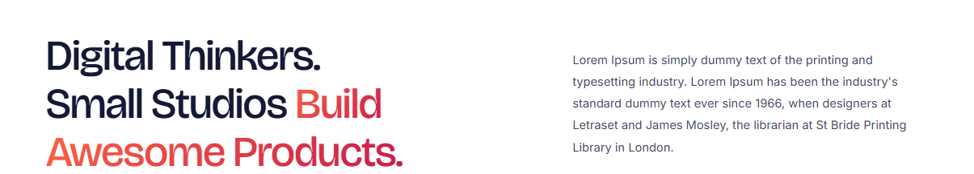

Why Choose Our AI Automation Services?
We work on actual real-world automation that can help address the real-world challenges that businesses face. Our unique selling point lies in our customized approach, in-depth understanding of your processes and focus on generating scalable AI solutions and supporting productivity and sustainable growth.

Business Process Automation Services


Business Process Automation Services
We at Ink Pixel Studio aim to make business life easier with custom Business Process Automation (BPA) services that eliminate manual processes, enhance accuracy and boost productivity. We create solutions that meet your workflow needs from workflow automation and automated data entry to task management, reporting and system integration. Our business automation solutions can save teams time, cut down on repetitive tasks and enable them to concentrate on more valuable tasks.
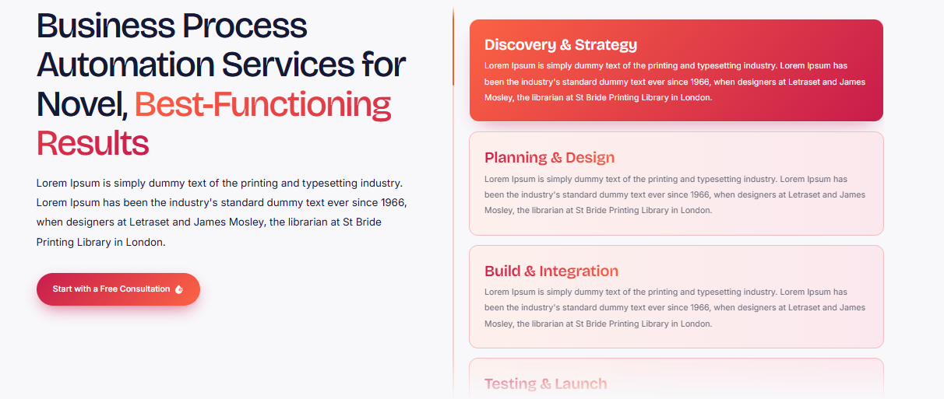

Why choose us?
We take the time to get to know your current processes before proposing a suitable automation solution. Our unique approach, detail-oriented service, and emphasis on solutions tailored to your business, not your system are what sets us apart. Whether you're looking to automate individual processes or optimize processes across multiple departments, our process automation services help ensure more consistent, efficient, and scalable processes that can adapt as your business evolves.
1. Workflow Analysis: We examine your existing processes and determine areas of repetition, bottlenecks and opportunities to automate.
2. Strategy & Planning: We define your automation objectives and pick the right tools for your business needs.
3. Solution Development: We setup and build automated business processes based on your enterprise.
4. Testing & Optimization: Workflows are tested, problems are solved and processes are optimized for reliable performance.
5. Implementation & Support: We implement the solution into your operations and provide support and improvements when needed.
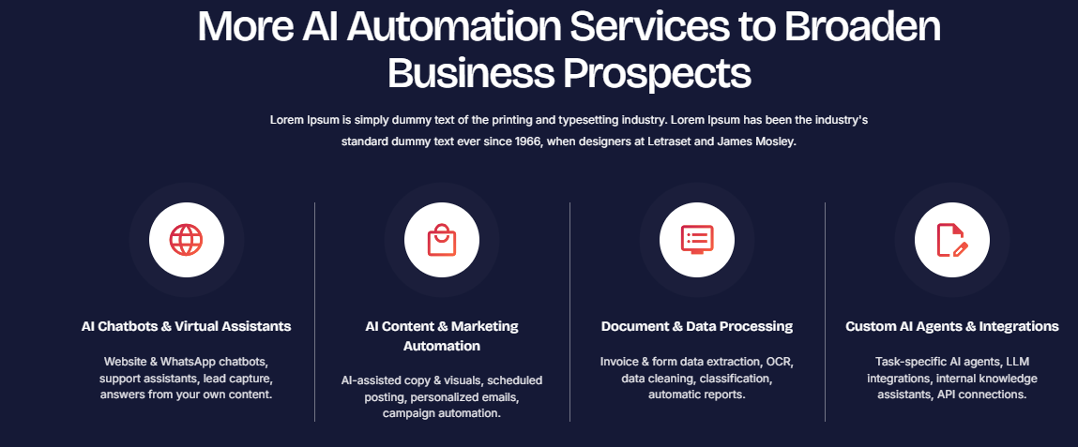

Broaden Your Businesses with Our Different AI Automation Services
Our AI software services enable automation of repetitive tasks, enhance customer interactions, and streamline daily operations for businesses. We at Ink Pixel Studio build custom, practical and scalable AI solutions, catered to your specific business objectives.
- AI Chatbots & Virtual Assistants
Use intelligent AI chatbots and virtual assistants to automate customer support, answer common questions, and give prompt assistance.
- AI Content and Marketing Automation
Find smart ways to create content, build campaigns and automate repetitive marketing with AI-based content and marketing automation tools.
- Document & Data Processing
Minimize manual workload and process document handling, data extraction, classification and information processing with AI driven data solutions.
- Custom AI Agent & Integration
Create intelligent custom AI agents which can complete specific tasks and communicate with other business tools and software.

Custom AI Agents & Integrations Services


Custom AI Agents & Integrations Services
Ink Pixel Studio designs bespoke AI agents and integration services to enable businesses to automate complex processes, integrate with current applications and systems, and enhance operational efficiency. Our AI agent development services empower businesses to manage repetitive tasks, extract data, aid decision-making, and orchestrate operations seamlessly between compatible platforms. Whether it's custom AI assistants, API integrations, or intelligent workflow connections, we create solutions to fit your unique business needs.
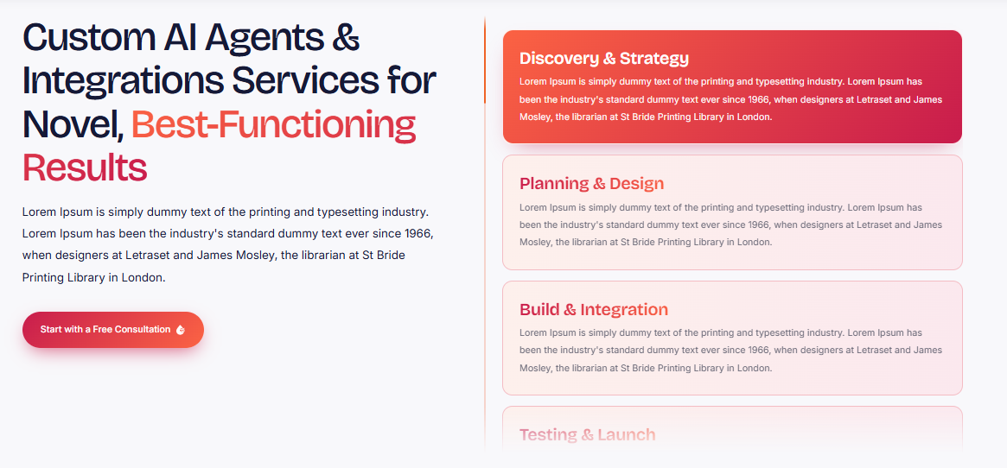

Why choose us?
We're interested in learning about your processes and where AI can offer your business real benefit. Our difference lies in our custom development approach, with seamless integration in mind, and our dedication to building solutions that are flexible to your current tech. From integration with business applications to automating multi-step processes, our AI integration services can help you create more intelligent workflows that can grow with your business.
1. Discovery & Requirement Analysis: We discover your business goals, repetitive tasks, current tools, and integration requirements.
2. Solution Planning: We set out the roles, processes, integrations and appropriate technologies for the AI agent.
3. AI Agent Development: Custom AI agents are developed and configured for specific tasks as per your requirements.
A. Integration & Testing: We integrate systems that can work together with APIs and automation methods, then we test functionality, data flow and reliability.
5. Deployment & Optimization: We deploy, monitor and optimize the solution as your business evolves.

Broaden Your Businesses with Our Different AI Automation Services
Our AI software services enable automation of repetitive tasks, enhance customer interactions, and streamline daily operations for businesses. We at Ink Pixel Studio build custom, practical and scalable AI solutions, catered to your specific business objectives.
- AI Chatbots & Virtual Assistants
Use intelligent AI chatbots and virtual assistants to automate customer support, answer common questions, and give prompt assistance.
- AI Content and Marketing Automation
Find smart ways to create content, build campaigns and automate repetitive marketing with AI-based content and marketing automation tools.
- Document & Data Processing
Minimize manual workload and process document handling, data extraction, classification and information processing with AI driven data solutions.
- Custom AI Agent & Integration
Create intelligent custom AI agents which can complete specific tasks and communicate with other business tools and software.

AI Chatbots & Virtual Assistants Services


AI Chatbots & Virtual Assistants Services
Ink Pixel Studio creates intelligent AI chatbots and virtual assistants to help businesses enhance customer engagement, reduce repetitive tasks, and offer prompt assistance. We offer a range of AI chatbot development services such as customer service chatbots, website chatbots, conversational AI assistants, and automated responses that cater to your business requirements. We combine Natural Language Processing (NLP) and appropriate AI technologies to develop solutions that facilitate search, navigation, and user interaction with services and information products, making the everyday life of the user easier.
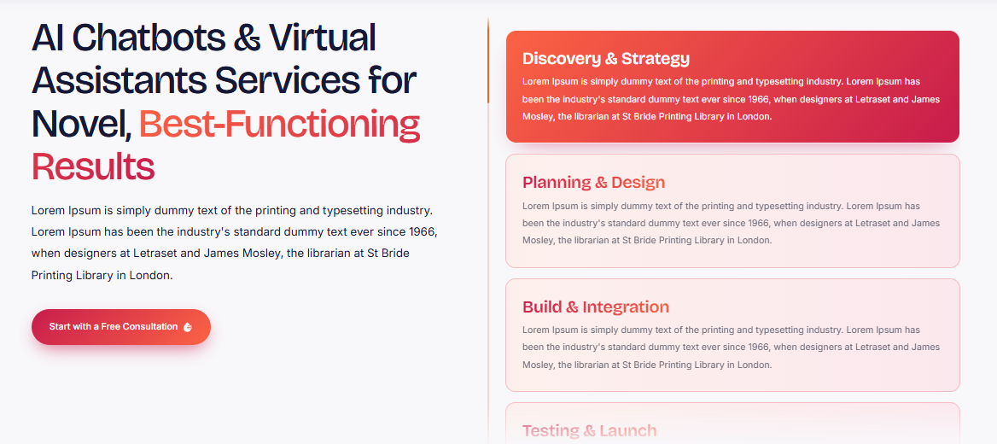

Why choose us?
We first get to know your customers, your business flows and your communications objectives, before designing a solution to meet your needs. This is because we operate in a more personalized way, design our solutions around your customer, and focus on creating practical, scalable customer support solutions that involve AI. From improving query efficiency to making services more accessible, we can help you make virtual assistants a part of your team, enhancing business growth.
1. Discovery & Planning: We define your objectives, the audience, questions you get asked frequently and the requirements of the chatbot.
2. Conversation Design: We draw out user journeys and design natural and easy-to-follow conversations.
3. Chatbot Development: We create your AI Chatbot or Virtual Assistant with the necessary features and answers.
4. Integration & Testing: We connect the chatbot to the compatible platforms and test its accuracy, usability and performance.
5. Deployment & Optimization: We deploy the solution, observe interactions and adapt the solution to the needs and feedback from users.

Broaden Your Businesses with Our Different AI Automation Services
Our AI software services enable automation of repetitive tasks, enhance customer interactions, and streamline daily operations for businesses. We at Ink Pixel Studio build custom, practical and scalable AI solutions, catered to your specific business objectives.
- AI Chatbots & Virtual Assistants
Use intelligent AI chatbots and virtual assistants to automate customer support, answer common questions, and give prompt assistance.
- AI Content and Marketing Automation
Find smart ways to create content, build campaigns and automate repetitive marketing with AI-based content and marketing automation tools.
- Document & Data Processing
Minimize manual workload and process document handling, data extraction, classification and information processing with AI driven data solutions.
- Custom AI Agent & Integration
Create intelligent custom AI agents which can complete specific tasks and communicate with other business tools and software.

Document & Data Processing Services


Document & Data Processing Services
Whether you're a business looking to streamline information management or a developer seeking a solution, Ink Pixel Studio offers intelligent document and data processing services that can benefit your business by minimizing manual tasks and optimizing operations. Our AI-based document processing solutions help to automate processes like document classification, digital record management, data extraction, and document sorting. We create workflows to streamline your information processing, whether you're dealing with invoices, forms, business reports or structured data.
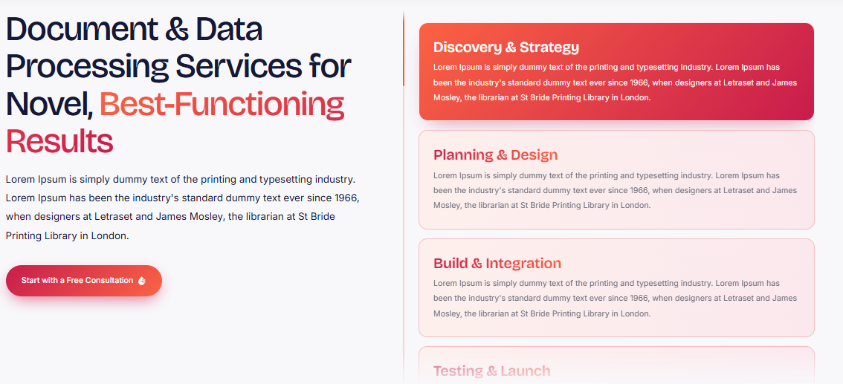

Why choose us?
We are interested in knowing your data needs and designing solutions to the processes you already have in place. Our unique approach, attention to detail, and focus on practical automation over unnecessary complexity is what sets us apart. Our intelligent data extraction solutions, when paired with the right AI tools and workflow integration, can enhance the accessibility of information, minimize repetitive tasks, and build more streamlined and scalable data management processes for businesses.
1. Requirements Analysis: We evaluate your documents, data sources, processing requirements and current workflows.
2. Solution Planning: Identify appropriate AI data processing tools and establish an effective data processing workflow.
3. Automation Development: We set-up the solutions for Data Extraction, Document Classification and Information Organization.
4. Testing & Validation: Testing the accuracy of data, consistency of processing, and performance of the workflow with refinement of issues as necessary.
5. Integration & Support: We ensure that the solution is integrated into compatible business systems and make continuous enhancements based on evolving requirements.

Broaden Your Businesses with Our Different AI Automation Services
Our AI software services enable automation of repetitive tasks, enhance customer interactions, and streamline daily operations for businesses. We at Ink Pixel Studio build custom, practical and scalable AI solutions, catered to your specific business objectives.
- AI Chatbots & Virtual Assistants
Use intelligent AI chatbots and virtual assistants to automate customer support, answer common questions, and give prompt assistance.
- AI Content and Marketing Automation
Find smart ways to create content, build campaigns and automate repetitive marketing with AI-based content and marketing automation tools.
- Document & Data Processing
Minimize manual workload and process document handling, data extraction, classification and information processing with AI driven data solutions.
- Custom AI Agent & Integration
Create intelligent custom AI agents which can complete specific tasks and communicate with other business tools and software.

AI Consulting & Training Services


AI Consulting & Training Services
Ink Pixel Studio is committed to empowering businesses to leverage AI for their benefit by offering custom AI consultation and training services. We will evaluate your business requirements, pinpoint where you can implement AI, and propose feasible strategies to streamline processes, enhance productivity, and facilitate better decision-making. We offer AI Strategy Consulting, Automation Planning, Tool Selection, Employee Training, and guidance for integrating AI into existing operations.
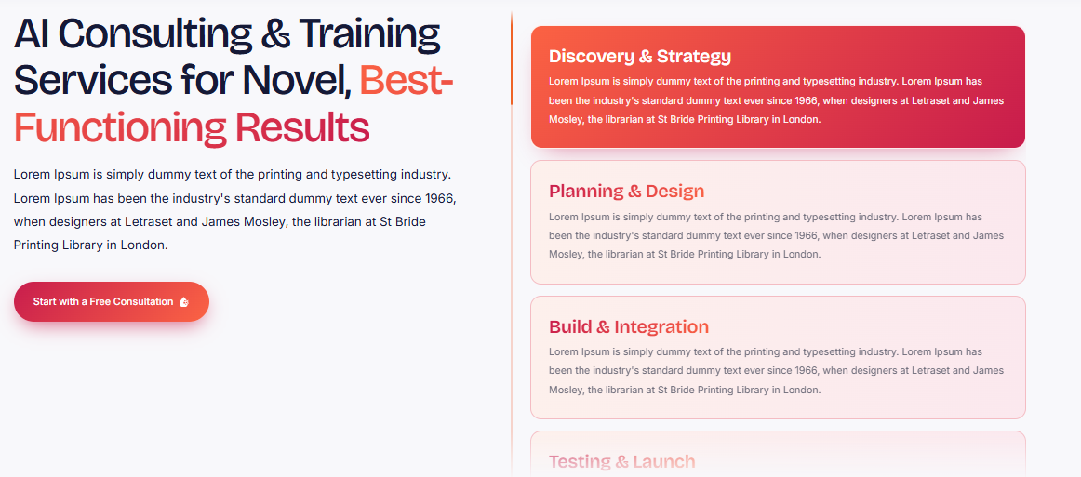

Why choose us?
Our attention is directed to your business objectives, your existing skills and weaknesses, and the technologies you need, not those that don't. The unique aspect of our approach is our customization, practical support, and focus on equipping teams with practical knowledge of effective AI usage in their workflows. From novice to seasoned user, our AI Consulting solutions enable businesses to make well-informed technology choices and develop the expertise to meet evolving business needs.
1. Business Assessment: We assess your workflows, problems, goals and preparedness for AI integration.
2. AI Opportunity Identification: Identification of appropriate AI tools and automation opportunities for your business.
3. Strategy Development: We develop a viable implementation roadmap for AI solutions with prioritization.
4. AI Training & Guidance: Custom AI training for your team to understand relevant tools, workflows, and applications.
5. Implementation Review & Support: Review progress, address issues, and make recommendations to enable continued AI adoption.

Broaden Your Businesses with Our Different AI Automation Services
Our AI software services enable automation of repetitive tasks, enhance customer interactions, and streamline daily operations for businesses. We at Ink Pixel Studio build custom, practical and scalable AI solutions, catered to your specific business objectives.
- AI Chatbots & Virtual Assistants
Use intelligent AI chatbots and virtual assistants to automate customer support, answer common questions, and give prompt assistance.
- AI Content and Marketing Automation
Find smart ways to create content, build campaigns and automate repetitive marketing with AI-based content and marketing automation tools.
- Document & Data Processing
Minimize manual workload and process document handling, data extraction, classification and information processing with AI driven data solutions.
- Custom AI Agent & Integration
Create intelligent custom AI agents which can complete specific tasks and communicate with other business tools and software.

Case Studies

Terminal Gateway CRM Case Study
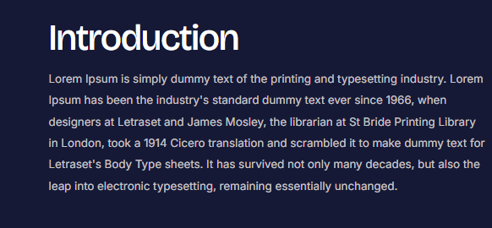

Introduction
Terminal Gateway CRM is a complete business management solution for consolidating the critical business functions into a single workspace. The platform's development is designed to integrate customer relationship management, sales tracking, project management, team communication, and file storage, providing a more streamlined and efficient approach for businesses to manage their daily operations. Integrated tools and a unified dashboard simplify the way teams access vital information, coordinate tasks and track business activity without the constant need to switch to a different app. The aim is to make processes easier and give a comprehensive overview of the business at a single glance.
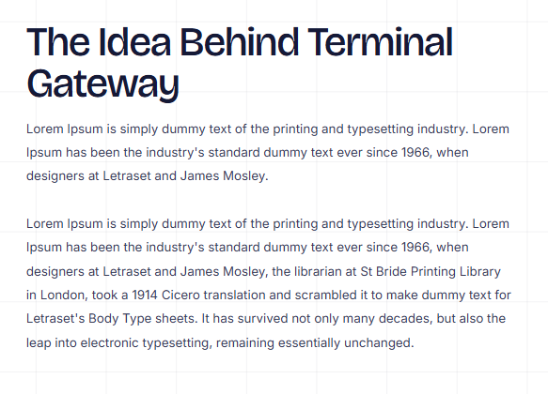

The Idea Behind Terminal Gateway
The concept behind Terminal Gateway was to come up with a single CRM system that brings together all moving parts of a business. Customer conversations, sales leads, project deadlines, team files and performance data can often be in different tools, making it difficult to manage information consistently. These are the critical capabilities combined in a reachable environment: Terminal Gateway. The platform aims to seamlessly integrate customer management, collaboration, and project organization to keep teams connected, ensure visibility of all their work, and streamline business activities with a more efficient digital experience.


The Challenge
As a business expands, there are countless demands on the business owner to manage customer connections, sales schedules, deadlines, internal communications and documents, all at once. These tasks become fragmented across separate applications, which can lead to increased time spent looking for information, switching between tools and coordinating updates. This disintegration can be harder to manage and keep track of customer communications and project progress. The problem was to overcome the typical operational challenges with a centralized business management system that gathers all the information needed and simplifies everyday business workflow.
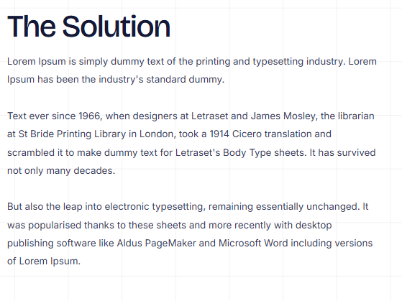

The Solution
These challenges are overcome with Terminal Gateway's single CRM and business management platform, bringing together customer data, sales activity, team communication, project workflows, shared files and customer analytics. It offers a dashboard view of key business activity and a centralized inbox, allowing teams to keep conversations organized in one place. Task coordination and deadlines are facilitated with project boards, templates and a common calendar and the shared file space of My Drive is used for team files. Customer Analytics gives an added layer of visibility and includes information on customer sentiment, distribution and demographics. These characteristics make for a more cohesive environment in which to run the day-to-day business.
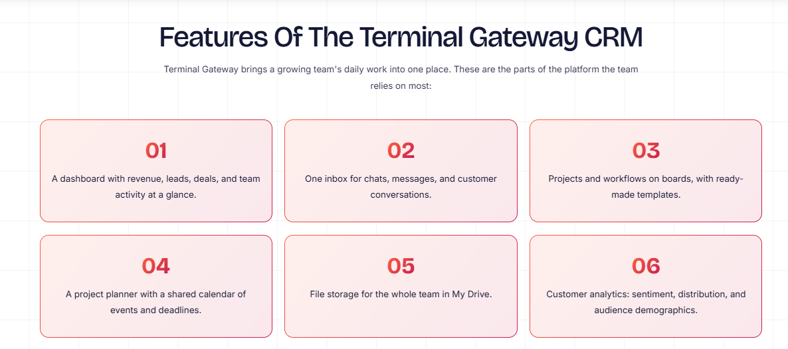

Six Features of the Terminal Gateway CRM
1. Centralized Business Dashboard
View revenue, leads, deals, and team activity from one dashboard for a clearer overview of business operations.
2. Unified Communication Inbox
Bring chats, messages, and customer conversations into one accessible inbox to simplify communication management.
3. Project & Workflow Management
Organize projects, manage workflows, and use ready-made templates to help teams structure their work efficiently.
4. Project Planner & Shared Calendar
Coordinate events, track important deadlines, and keep team schedules organized through a shared planning calendar.
5. My Drive - Team File Storage
Keep business files in a shared digital workspace so team members can access and organize important documents.
6. Customer Analytics & Insights
Explore customer sentiment, distribution, and audience demographics to better understand customer patterns and business audiences.

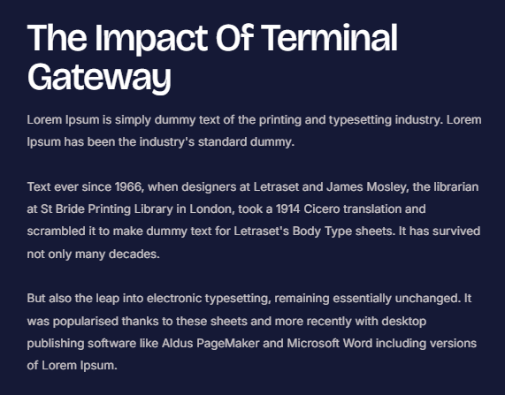

The Impact of Terminal Gateway
By making businesses more connected, Terminal Gateway offers a better approach to organizing everyday operations. This integration streamlines the process of customer conversations, sales visibility, project planning, file storage, and customer analytics, all of which reduce the need to navigate between multiple tools. Teams will be able to locate pertinent information more quickly, collaborate on projects using shared workflows, and have a better sense of what is happening. Additionally, its centralized system establishes an environment for greater uniformity in collaboration and smart company choices. Instead of using fragmented systems, businesses can have one integrated workspace to help them manage their work day to day and future operational requirements.
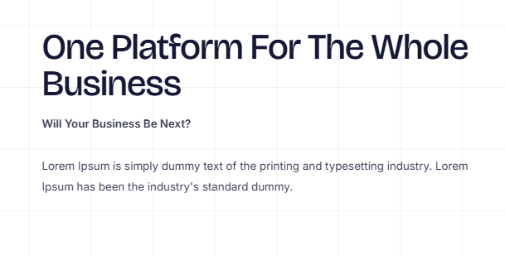

One Platform For The Whole Business
Terminal Gateway integrates CRM, sales, communications, project management, file storage and customer analytics all in one place.
With a single, unified workspace, businesses can gain access to the tools and information they need for managing customer relationships and coordinating internal work.

Gulbaan Case Study


Gulbaan
Gulbaan is a flower retail and delivery company that delivers fresh and quality flower arrangements to people all around Lahore and Islamabad. Gulbaan is made for those who want to celebrate special occasions, express emotions, and make someone's day brighter, providing a convenient solution to explore and order flowers online.
The platform emphasizes quality, ease of access, and a wonderful shopping experience, enabling customers to explore a growing selection of flowers. Gulbaan's flower gifting allows you to discover and send flowers while enjoying the benefit of eCommerce.
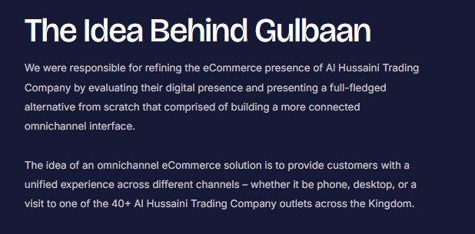

The Idea Behind Gulbaan
Gulbaan was conceived to revolutionize the online flower retailing landscape by making it more connected and accessible to enable customers to easily discover and order high-quality flowers online.
The aim was to introduce the elegance of the traditional gift of flowers to a digital world with an easier way for customers to browse collections and select flowers for various occasions. Gulbaan's goal is to make the shopping process for their flowers easier by creating an engaging website to go with. It's a part of the platform's efforts to build on the idea of a seamless digital shopping experience with a touch of personalization that makes gifting flowers so special.

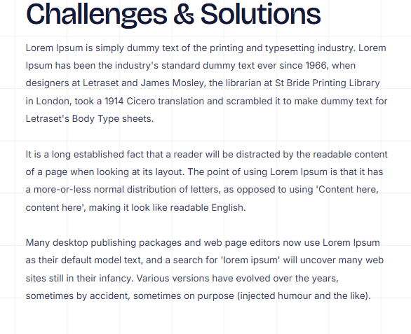

Challenges & Solutions
Showcasing products is not enough to create an engaging online flower retail experience. Customers must have a seamless experience when navigating floral choices, comprehending their options and finalizing their purchase in a convenient manner. Gulbaan's digital experience had to look great when it came to showcasing flowers online and ensuring it was accessible for customers in Lahore and Islamabad to purchase flowers online.
The focus was to develop a dedicated eCommerce solution, highlighting the floral line in a welcoming e-commerce environment. The platform focuses on product discovery, easy navigation, and a hassle-free ordering process, ensuring a seamless shopping experience and aiding customers in finding the flowers they desire to send.

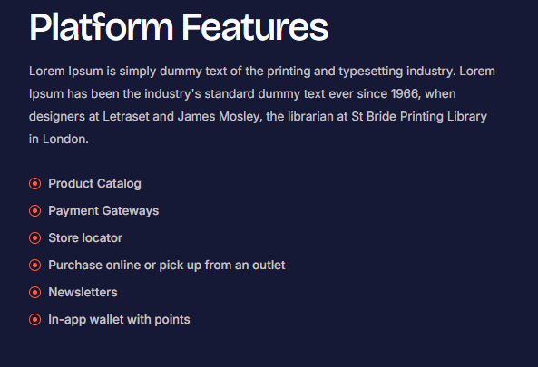

Platform Features
Gulbaan's online shopping experience brings essential features together to make flower discovery and ordering more convenient.
- Floral Product Collection: Explore a selection of fresh, premium flowers for different gifting needs.
- Online Shopping Experience: Browse products through a dedicated digital storefront.
- Product Discovery: Navigate floral options and find arrangements suited to different occasions.
- Convenient Ordering: Place flower orders through an accessible online shopping journey.
- Location-Focused Service: Shop for flower delivery services available across Lahore and Islamabad.
- Digital Brand Experience: Enjoy an online storefront designed to showcase Gulbaan's floral offerings and brand identity.

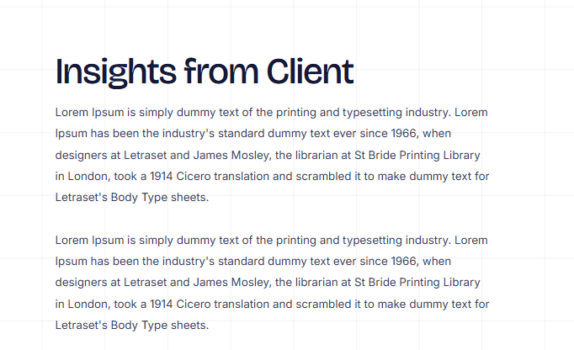

Insights from Client
The project is a testament to the significance of creating a traditional shopping experience accessible online. A flower delivery service like Gulbaan requires customers to have an online experience that is as pleasing to the eye, but as simple as buying real flowers. The success of the brand's fresh, high-quality flowers in Lahore and Islamabad sets a solid base for their digital presence.
These priorities emphasize the importance of having an inviting storefront, good product presentation and a convenient customer journey. Gulbaan can enhance the online journey to mirror the emotional essence of gifting flowers, making it more personal and accessible.
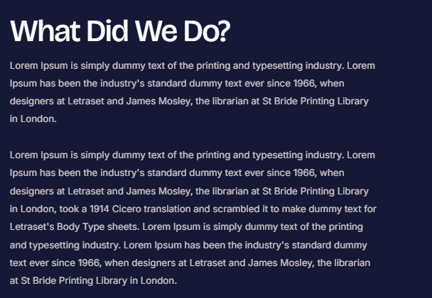

What Did We Do?
We concentrated on building Gulbaan's online presence in the realm of its floral products and delivery services. The strategy was to create a welcoming online environment for presenting products and facilitate a transparent and convenient shopping experience. The way the front page is set up to discover products and make it easy for customers to navigate the store encourages customers to learn about the flowers and progress to ordering.
Gulbaan's digital experience was built to embody its brand identity and render online flower shopping accessible. With this work, people in Lahore and Islamabad have a dedicated channel to find out about the products and the flower retail and delivery service of the brand.
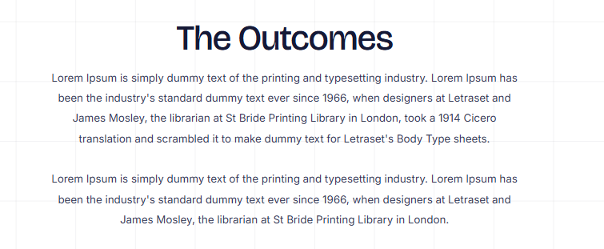

The Outcomes
The online platform by Gulbaan provides an online hub for customers to buy fresh flowers. The floral service has taken its floral collection to an easily accessible online store, allowing customers to find their floral products without just using the traditional shopping method.
The platform also provides Gulbaan with a digital platform to communicate its brand name, highlight its products and services and reach out to its customers in Lahore and Islamabad. As a product discovery and convenience-based shopping platform, Gulbaan can help facilitate its flower delivery service with an easier online experience that enhances the personal meaning of flowers.
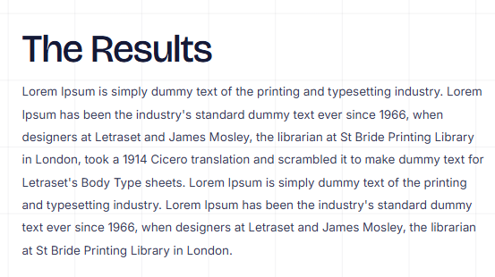

The Results
Overall, the Gulbaan project will lay the groundwork for a more user-friendly online flower shopping experience in the target markets. The brand's digital storefront is making the flowers more accessible to people, allowing them to browse what they have to offer and order digitally. It also helps to reinforce Gulbaan's digital identity by offering its service via a dedicated eCommerce channel.
Although specific performance metrics like sales growth, conversion rates or customer acquisition outcomes were not disclosed, the project showcases the potential of a targeted digital shopping experience for a flower retail and delivery enterprise. Gulbaan is set to bring its high-quality floral collection to the customers who want a hassle-free option for sending flowers in Lahore and Islamabad.

Privacy Policy

Introduction
Welcome to Ink Pixel Studio. We value your privacy and take seriously your personal information that you disclose to us via our site, contact forms, consultations or business interactions.
This Privacy Policy tells you how we collect, use, store, disclose, or protect information during your visits to this website or when you inquire about our services or use our services. We provide website design and development, software development, mobile application development, AI automation, branding, digital marketing, and technology solutions.
The use of our website or the giving of your information to us is an acknowledgement of the practices outlined in this policy. If consent is required by applicable law, we will seek consent separately.

Information We Collect
Based on how you use our website and services, we might collect the following types of information:

2.1 Personal Information
We may collect the following information when you contact us, request a consultation or ask about a project:
- Full name
- Email address
- Telephone number
- The name of the company or organization.
- Business Address (if applicable)
- Data that is submitted via contact forms
- Connective ideas and question information

2.2 Project and Business Information
We may gather information required to comprehend and complete your project, such as your business needs, project briefs, brand materials, website content materials, design references, software requirements, and other documents that you voluntarily submit.
Please refrain from sharing highly personal and confidential information unless it is required to provide the agreed service and safeguards are appropriate.

2.3 Technical and Usage Information
As you use our website, some information may be automatically gathered, such as:
- IP address and approximate location derived from the IP address.
- Browser type and device information
- Operating system
- The number of pages visited and the amount of time spent on the web site.
- Went to a website or engaged in general browsing activity and referred websites to others.
- Information about the performance of the website, the diagnosis information, and the error information.
- The information gathered will be dependent upon website technologies and tools being used.
- Cookies and other similar technologies are also used. Other technologies, such as cookies, are also used.
Cookies, pixels, tags and similar technologies are used on our website to facilitate the website's functionality, for storing preferences, for understanding the behavior of visitors, for measuring the performance of marketing actions and otherwise.
Non-essential cookies will only be installed where necessary following the proper consent. Consent can also be managed via your browser settings, or any consent-management tool you can find on our site.
Some aspects of the website may be affected if you block some of the cookies.

3. Use of Your Information
Collected information can be used by Ink Pixel Studio for:
- Answer queries and provide advice on request.
- Compose project proposals, quotations, and service agreements.
- Provide website, software, application, branding, marketing, and AI services.
- Provide updates on projects, feedback, deadlines, and project deliverables.
- Process invoices and payments and manage relevant business documentation.
- Run, troubleshoot and enhance our site and services.
- Customize suggestions for services based on individual needs.
- Deliver marketing communications as appropriate and when necessary and with consent.
- Identify, investigate and deter misuse, security incidents and fraud.
- Comply with relevant legal, regulatory, accounting and contractual requirements.
- Safeguard our legal rights and arbitrate disputes.
We will not use personal information for purposes that are substantially different from those described here unless we have an appropriate legal basis for doing so or give additional notice if required.

4. Legal Basis for Processing
The information we process on any of the following bases may apply to you depending on the jurisdiction that applies to you:
Permission to perform a task; consent: When you have given permission for a specific purpose.
- Contract: If it is required to provide a service or take any steps asked in advance before entering into a contract.
- Legitimate interests: Where processing is considered to be necessary for a business purpose, for the improvement of services, to ensure security or to prevent fraud, and is not outweighed by the rights of the individuals involved.
- Legal requirements: If the law requires it.
- Other legally valid reasons: If identified by the laws that apply to the person and the business.
Consent may be withdrawn where consent is a legal basis for processing. If processing is conducted lawfully before withdrawal, it will not be affected by withdrawal.
Students will learn how to share information in an appropriate manner.

5. How We Share Information
We do not barter personal information for payment. We will share information in the following cases, if it is appropriate and lawful:

5.1 Service Providers
We may disclose information to trusted providers, which is necessary for us to carry out our business, including:
- Web Hosting and infrastructure Providers
- Services for cloud storage and file sharing.
- Payment processors
- These are customer relationship management and communication platforms that are used to deal with customers.
- Analytics and website performance companies
- Email and marketing platforms.
- Software, App & AI Technological providers
These providers may handle information as they see fit and per their own privacy policies. We employ suitable contractual and security arrangements to safeguard information, when required.

5.2 Project Partners and Subcontractors
Relevant information relating to the project may be shared with appropriately authorized team members, developers, designers, consultants or subcontractors as may be required to provide the services agreed. Access shall be restricted to that which is "necessary and reasonable" in performance of the work.

5.3 Legal and security requirements
We might disclose information when required to do so by law for any proper legal reasons, or if we are asked to, for our rights, to investigate suspected fraud and to protect the safety and security of our business or users, or others.

5.4 Business Transfers
In the event of our business being merged or acquired, restructured or asset sold, information may be transferred in accordance with applicable laws and reasonable safeguards.

6. AI Tools and Automated Processing
AI-powered tools or external AI services provided by Ink Pixel Studio can be used in various capacities to support tasks in the studio, such as workflow automation, content processing, software development, chatbot features, and data organization.
If these tools are used to process client data, then we will take reasonable steps to ensure that appropriate services and configurations are used for the agreed purpose. This does not mean, however, that third-party providers do not have their own data-handling practices.
Confidential, sensitive, or regulated data must not be provided to AI tools without evaluation and proper permissions and protection.
Output produced by the AI might be incorrect or misinformed, and may need to be checked if human verification is required. Automated processing is not the only basis by which we make decisions about individuals with legal or other significant consequences unless there is an appropriate legal basis and required safeguards.

7. Data Retention
We keep personal data as long as it is sufficient for the purpose for which it was submitted, such as delivering services, managing projects, maintaining records, resolving disputes, ensuring security and legal compliance.
The retention periods can differ depending on the information type, nature of services, contractual requirements and regulation.
Subject to legal requirements and legitimate recordkeeping needs, reasonable measures will be implemented to remove, anonymize or securely dispose of information when it is no longer necessary.
Unless otherwise stated in a written agreement with the client, important files and deliverables for the project should be kept by the client.

8. Data Security
Reasonable administrative, technical and organizational measures are put in place to prevent the loss, destruction, disclosure, alteration, unauthorized access to personal data.
But none of the websites, digital storage systems, email sending or online services can be assured to be absolutely safe. We will therefore not guarantee complete protection.
It is your responsibility to ensure that your account information is kept secure, that you use secure communication methods when appropriate, and that you report promptly any suspicious activity involving your account which may involve interaction with us.

9. Your Privacy Rights
These are the rights you may have under the laws that apply to you:
- Ask us for information about you that we have.
- Ask for a correction of incorrect or incomplete information.
- Ask to have personal data removed, under specific conditions.
- Request restrictions on certain processing activities.
- Resist some processing, such as some direct marketing.
- Ask for a hard copy of some information.
- Withdraw consent if processing is based on consent.
- Complaint to an appropriate data protection authority.
These rights are not unlimited, and are subject to legal exceptions.
A privacy request may be made by sending a message to us using the contact information or the contact form available on our website. Please be aware that we might need to verify your identity before we respond. We will reply within the time limits specified by the applicable laws.

10. Marketing Communications
Service communications - may be sent regarding inquiries, proposals, project status, invoices, support etc.
Also, promotional communications may be sent as allowed by law. To opt-out of marketing emails, use the unsubscribe link, if available, or reach out to us.
Refusing to receive marketing related communications will not stop us sending essential messages in connection with an active project, payment or contractual obligation.

11. Third-Party Websites and Services
We may include links to other resources online, applications, payment services, social media platforms or other websites.
We are not responsible for the privacy practices, content or security of those third parties. Utilizing or visiting their services will be as per their respective terms and policies concerning privacy.
Please be sure to carefully consider those policies before entering personal information into any external service.

12. International Data Transfers
Personal information may be processed or stored in other countries than the country of your residence depending on our service providers, business operations and your location.
If there are international transfers where safeguards are required by the applicable law, we will take reasonable steps to provide the safeguards required by that law.

13. Children's Privacy
Our website and business services are for use by businesses and individuals who are legally allowed to use them. We do not knowingly solicit personal information directly from children where it is legally necessary and do not collect personal information directly from children unless this is legally required.
If you think a child has given us personal information that they shouldn't have, please write to us to help us understand what has happened and what action to take.

14. Changes to This Privacy Policy
We reserve the right to modify this Privacy Policy from time to time to address changes in the services, technologies being used on the Web, our business or legal requirements.
This updated version will be published on this page and will have an updated revision date. If required by law, we will give further notice or obtain consent for changes to the material.

15. Contact Us
For any questions on this Privacy Policy, exercise of the privacy rights and/or information about the processing of personal data, you can contact Ink Pixel Studio on the official contact form or on the contact data provided on our website.

Terms & Conditions

1. Introduction and Acceptance
Welcome to Ink Pixel Studio. These Terms and Conditions govern your access to and use of our website, communications, and services.
Ink Pixel Studio provides digital services that may include website design and development, custom software development, mobile application development, AI automation, AI consulting, branding, digital marketing, and related technology solutions.
By accessing our website, submitting an inquiry, accepting a proposal, or engaging our services, you agree to these Terms and Conditions to the extent applicable to your interaction with us. A separate signed agreement, proposal, statement of work, or service-specific contract may establish additional terms for a particular project.
If you do not agree to these terms, please discontinue use of the website and do not engage our services.

2. Eligibility and Business Information
You must be legally capable of entering into a binding agreement to purchase our services.
If you act on behalf of a company or other organization, you confirm that you have the authority to represent that organization and accept contractual obligations on its behalf.
Before entering into a service agreement, the applicable legal business name, business registration details where required, contact information, and other necessary contracting information should be confirmed.

3. Our Services
Ink Pixel Studio may provide services including, but not limited to:
- Website design, development, maintenance, and optimization
- Custom software and business process automation
- iOS and Android application development
- App maintenance, scaling, and technical support
- AI chatbots, virtual assistants, and custom AI agents
- AI consulting, training, and system integrations
- Document and data processing solutions
- Branding and visual identity services
- Digital marketing, search engine optimization, and social media services
The exact scope, deliverables, pricing, timeline, revision limits, and support arrangements for each project will be established in the applicable proposal or written agreement.
Descriptions on our website are general service summaries and do not automatically include every feature or deliverable for every project.

4. Project Proposals and Agreements
Before work begins, we may provide a proposal, quotation, project brief, or statement of work describing the agreed services.
Depending on the project, the agreement may specify:
- Scope of work and deliverables
- Project milestones and estimated timeline
- Fees, deposits, and payment schedule
- Client responsibilities and required materials
- Included revisions and approval procedures
- Hosting, licensing, integrations, and third-party costs
- Ownership and licensing rights
- Maintenance, warranty, and support arrangements
- Cancellation and refund terms
A project will ordinarily begin after the required approvals, information, and initial payment have been received, unless otherwise agreed in writing.
Any material change to the approved scope may require a revised quotation, adjusted timeline, or additional payment.

5. Client Responsibilities
Clients are responsible for providing accurate information, timely feedback, and the materials reasonably necessary to complete their projects.
You agree to:
- Provide complete and accurate project requirements.
- Supply content, images, brand assets, credentials, and approvals when needed.
- Confirm that you have permission to use all materials provided to us.
- Review deliverables and communicate requested changes within agreed timelines.
- Maintain appropriate backups of your original files and important business data.
- Obtain any permissions, licenses, or consents required for your business operations.
- Ensure that instructions and supplied materials comply with applicable laws.
- Maintain control over your own accounts and credentials unless account management is expressly included.
- Delays in receiving materials, feedback, approvals, or access may affect delivery dates and project costs.
We are not responsible for delays or defects caused by incomplete instructions, inaccurate client-provided information, unauthorized changes, or third-party systems outside our reasonable control.

6. Pricing and Payments
Prices, payment schedules, deposits, and applicable charges will be communicated in the relevant proposal, invoice, or written agreement.
Unless otherwise agreed:
Payments must be made according to the agreed schedule.
Work may be paused if required payments are overdue.
Additional requests outside the agreed scope may incur additional charges.
Third-party costs, including software subscriptions, hosting, domains, API usage, paid plugins, stock assets, and advertising spend, are the client's responsibility unless expressly included in writing.
Taxes, duties, and similar charges will be handled according to applicable law and the agreed pricing terms.
If a payment is disputed, the parties should communicate promptly and attempt to resolve the issue in good faith. Any late-payment charges or collection costs must be specified in the applicable agreement and permitted by law.

7. Revisions, Approvals, and Change Requests
The number and type of revisions included in a project will be determined by the applicable proposal or agreement.
A revision generally means an adjustment to an existing deliverable within the agreed scope. A new feature, additional page, substantial redesign, new integration, or change to previously approved requirements may be treated as additional work.
Clients are responsible for reviewing deliverables and providing clear, consolidated feedback within the agreed review period.
Approval may be provided in writing or through another agreed project approval method. Approval of a deliverable may authorize the next project stage, including deployment, publication, or final file delivery.

8. Timelines and Delivery
Project timelines are estimates unless a specific deadline is expressly agreed in writing.
Delivery may depend on client feedback, content availability, approvals, payment, third-party access, app-store reviews, hosting providers, or other external requirements.
We will make reasonable efforts to follow the agreed schedule, but we cannot guarantee that external reviews, integrations, or third-party services will be completed within a particular timeframe.
If a project is delayed, the parties should discuss the cause and agree on reasonable next steps.

9. Intellectual Property Rights

9.1 Client Materials
You retain ownership of materials you provide to us, subject to any rights held by third parties. You grant us permission to use those materials only as reasonably necessary to perform the agreed services.
You confirm that you have the rights and permissions required to provide those materials for the intended use.

9.2 Project Deliverables
Ownership of final deliverables will be determined by the applicable written agreement.
Where the agreement provides for transfer of ownership, the transfer will take effect upon satisfaction of the stated conditions, which may include full payment.
Unless expressly transferred, we retain ownership of our pre-existing tools, reusable code, frameworks, templates, methods, processes, know-how, and other materials developed independently of the client project.

9.3 Third-Party Materials
Third-party fonts, images, plugins, libraries, software, APIs, AI models, and other components may be subject to separate licenses or terms.
Your rights to use such materials are governed by the relevant third-party terms. Additional license fees may apply.

9.4 Portfolio and Promotion
We will not publicly disclose confidential client information without appropriate authorization. If we wish to display a client project, name, logo, or deliverable in our portfolio or marketing materials, we will obtain permission where required by the applicable agreement or law.

10. Confidentiality
Each party may receive confidential business, technical, financial, or project information from the other.
The receiving party agrees to use such information only for the agreed business purpose, limit access to authorized individuals who need it, and take reasonable measures to protect it.
Confidentiality obligations do not ordinarily apply to information that is publicly available through no breach, already lawfully known, independently developed, or lawfully received from another source.
Where a separate nondisclosure agreement applies, its terms will govern the relevant confidential information.

11. Website Use and Acceptable Conduct
You agree not to:
- Use our website for unlawful, fraudulent, or misleading purposes.
- Attempt to gain unauthorized access to our systems or accounts.
- Introduce malicious code or interfere with website functionality.
- Copy, scrape, or exploit website content in violation of applicable law or intellectual property rights.
- Submit content that infringes third-party rights or violates applicable law.
- Misrepresent your identity or authority when contacting us.
- Interfere with the use of our website by other visitors.
We may restrict access to our website where reasonably necessary to protect security, comply with law, or address misuse.

12. AI Services and Automated Solutions
Our AI-related services may include chatbots, virtual assistants, AI agents, content workflows, document processing, and integrations with third-party tools.
AI systems can produce incomplete, inaccurate, outdated, or unexpected results. Clients are responsible for reviewing AI-generated outputs where accuracy, legal compliance, safety, or business judgment is important.
Unless expressly agreed otherwise, our AI solutions are intended to support business processes rather than replace necessary human review or professional judgment.
Clients must ensure they have the right to use any data submitted to AI systems and must not provide personal, confidential, regulated, or sensitive information without appropriate authorization and safeguards.
We do not promise that AI systems will always be available, error-free, unbiased, or capable of producing a specific business outcome.

13. Third-Party Platforms and Integrations
Our services may rely on third-party platforms, including hosting providers, domain registrars, payment processors, app stores, analytics tools, APIs, advertising platforms, plugins, and software subscriptions.
These services may have their own terms, fees, technical requirements, and availability limitations.
We are not responsible for independent changes, outages, suspensions, pricing changes, security incidents, or policy decisions made by third-party providers, except to the extent liability cannot lawfully be excluded.
If a third-party service becomes unavailable or changes its functionality, additional work may be required to adapt the project.

14. Maintenance, Support, and Security
Maintenance, updates, bug fixes, monitoring, hosting, and technical support are included only where specified in the applicable agreement or package.
Unless expressly agreed, completing a project does not automatically create an ongoing maintenance obligation.
Clients are responsible for maintaining appropriate account access, credentials, backups, licenses, and security practices for systems under their control.
We will handle agreed maintenance work with reasonable care, but no digital system can be guaranteed to remain free from vulnerabilities, downtime, or compatibility issues.

15. Disclaimers
Our website and general service descriptions are provided for informational purposes.
Except for commitments expressly stated in a written agreement or rights that cannot be excluded by law, services are provided without implied warranties to the maximum extent permitted by applicable law.
We do not guarantee specific sales, traffic, search rankings, advertising results, conversion rates, revenue, user growth, or other business outcomes.
Results may depend on factors outside our control, including market conditions, client decisions, competition, third-party algorithms, platform policies, and user behavior.

16. Limitation of Liability
To the maximum extent permitted by applicable law, neither party will be liable to the other for indirect, incidental, special, exemplary, or consequential losses, including loss of profits, revenue, business opportunities, goodwill, or data, arising from the relevant services or these terms.
Subject to applicable law and any separate written agreement, our total liability arising from a particular project will not exceed the fees paid or payable to us for that project during the twelve months preceding the event giving rise to the claim.
Nothing in these terms excludes or limits liability where doing so would be unlawful, including liability that cannot legally be excluded for fraud, willful misconduct, or other protected rights.
Any limitation of liability must be interpreted consistently with mandatory consumer protection and other applicable laws.

17. Indemnification
To the extent permitted by law, you agree to be responsible for claims, losses, or expenses arising from materials you supply that infringe third-party rights, your unlawful use of the services, or your material breach of these terms.
This provision does not apply to the extent a claim results from our own breach, negligence, misconduct, or other conduct for which responsibility cannot legally be transferred.

18. Suspension and Termination
Either party may terminate a project in accordance with the applicable written agreement.
We may suspend services or access where reasonably necessary due to non-payment, unlawful activity, security concerns, material breach, or a third-party restriction affecting the work.
Upon termination, the parties will settle outstanding amounts and handle completed work, work in progress, access credentials, project files, and any transferable rights according to the applicable agreement and refund policy.
Termination does not remove obligations that accrued before termination or provisions intended to continue afterward, such as payment, confidentiality, intellectual property, and applicable liability provisions.

19. Privacy
Our collection and use of personal information are described in our Privacy Policy. By using our website, you acknowledge that you have had an opportunity to review that policy.
Where applicable law requires consent for specific processing activities, that consent will be obtained separately.

20. Governing Law and Disputes
These Terms and Conditions will be governed by the laws of the jurisdiction identified in the final published version of this policy, without regard to conflict-of-law rules, subject to mandatory legal protections that apply to you.
The parties will first attempt to resolve disputes through good-faith communication. If a dispute cannot be resolved informally, it may be referred to the courts or other dispute-resolution forum with appropriate jurisdiction under applicable law.

21. Changes to These Terms
We may update these Terms and Conditions to reflect changes to our services, business practices, or legal obligations.
Updates will be posted on this page with a revised date. Changes will apply prospectively unless otherwise permitted by law or agreed in writing.
Material changes to an existing project agreement will be handled in accordance with that agreement and applicable law.

15. Contact Us
For any questions on this Privacy Policy, exercise of the privacy rights and/or information about the processing of personal data, you can contact Ink Pixel Studio on the official contact form or on the contact data provided on our website.
Website: https://websiteagencyllc.com/projects/inkpixelstudio

Refund Policy

1. Introduction
At Ink Pixel Studio, we provide customized digital services designed around each client's requirements. Our services may include website design and development, software development, mobile application development, AI automation, branding, digital marketing, consulting, and related technology solutions.
Because these services often involve project planning, creative work, development time, resource allocation, and customized deliverables, refund eligibility depends on the project stage, work completed, payment terms, and applicable law.
This Refund Policy explains how we handle refund requests, project cancellations, payment disputes, and related concerns. It should be read alongside the relevant proposal, service agreement, and Terms and Conditions.

2. Scope of This Policy
This policy applies to payments made directly to Ink Pixel Studio for services, projects, or other offerings covered by our written agreements.
Certain charges may be governed by separate terms, including third-party software subscriptions, domain registrations, hosting services, advertising budgets, paid licenses, stock assets, API usage, and other external services.
Where a separate written agreement establishes specific refund terms for a project, those terms will apply to the extent they are lawful and consistent with mandatory consumer rights.

3. General Refund Principles
Refund eligibility is assessed based on the nature of the service and the stage at which a cancellation or refund request is made.
As a general proposed policy:
- Before work begins: A refund may be considered for eligible payments if the project has not started, subject to the written agreement, any disclosed non-refundable charges, and applicable law.
- After work begins: Refund eligibility may be limited to the portion of payment attributable to services not performed, where a refund is due under the agreement or applicable law.
- After partial delivery: Any eligible refund may take into account completed work, approved milestones, committed resources, and the terms of the agreement.
- After final delivery or approval: Completed and accepted work is generally not refundable except where required by law or expressly provided in the applicable agreement.
- For recurring services: Cancellation generally affects future billing, subject to the subscription terms, notice period, and applicable law.
These principles are not intended to remove any statutory rights or override a project-specific commitment.

4. Website Design and Development Refunds
Website projects may involve discovery, planning, wireframes, design concepts, development, testing, integrations, and deployment.
If a client requests cancellation:
- Before project work begins, we will review the payment terms and determine whether a refund is due.
- Once project work has begun, the value of work completed and any applicable contractual commitments may be considered when assessing a refund.
- If design concepts, development work, or other milestones have been delivered and accepted, those completed portions are generally not refundable unless the agreement or applicable law provides otherwise.
- If a project is incomplete due to an issue attributable to Ink Pixel Studio, we will review the circumstances and determine an appropriate remedy under the agreement and applicable law.
Domain registration, hosting, premium themes, plugins, third-party licenses, and other external charges may be non-refundable under the relevant provider's terms. We will identify such charges where reasonably possible before purchase.

5. Software and Mobile Application Development Refunds
Custom software and mobile application projects may require requirements analysis, technical architecture, interface design, coding, integration, testing, and deployment preparation.
Refund requests for these projects will be reviewed according to the agreed milestones and work completed.
- Work already completed and delivered will generally not qualify for a refund except where required by law or agreed in writing.
- Payments for work not yet performed may be considered for refund where appropriate under the contract and applicable law.
- Third-party API fees, software subscriptions, app-store charges, hosting fees, and external licenses are subject to their providers' refund policies.
- Additional features, revisions, or changes outside the original scope may involve separate charges and will be handled according to the relevant agreement.
If a delivered feature does not meet an expressly agreed specification, the client should notify us with sufficient details so that we can assess the issue and determine the appropriate contractual remedy.

6. AI Automation, Consulting, and Integration Services
AI-related projects may include workflow analysis, AI agent configuration, chatbot development, integrations, training, testing, and implementation.
Refund requests for these services will be assessed based on the agreed scope, work completed, deliverables supplied, and applicable agreement.
AI systems and third-party tools may produce variable results or change over time. A result that differs from an expected business outcome does not automatically establish refund eligibility unless a specific outcome or acceptance criterion was expressly agreed in writing or a refund is otherwise required by law.
Where an agreed deliverable fails to meet a documented requirement, we will review the issue and consider appropriate corrective work, replacement, partial refund, or another remedy where required or agreed.

7. Branding, Design, and Digital Marketing Refunds
Creative and marketing services may include branding, logo design, graphics, social media content, search engine optimization, advertising setup, and campaign management.
Refund eligibility may depend on the work completed, concepts or content delivered, campaign activities performed, and the applicable agreement.
- Completed and approved creative deliverables are generally not refundable except where required by law or agreed in writing.
- Requests to change creative direction after approval may be treated as additional work.
- Advertising budgets paid to advertising platforms are separate from our service fees and are subject to the platform's terms.
- Marketing performance, audience response, search rankings, leads, and sales may vary and are not guaranteed unless a specific written agreement provides otherwise.
If a deliverable does not meet an expressly agreed requirement, please notify us so that we can review the concern and determine an appropriate remedy.

8. Deposits and Advance Payments
Some projects require an advance payment or deposit to reserve resources and begin work.
Any deposit described as non-refundable must be clearly disclosed and agreed to before payment, and may be retained only to the extent permitted by applicable law.
If a client cancels after work has begun, we may assess the value of work completed and documented, approved project expenses, and other charges permitted by the agreement and law.
We will not rely on this policy to retain an amount that must legally be refunded.

9. Cancellation Requests
Clients who wish to cancel a project or service should submit a written request through the official contact form or contact details published on our website.
Please include:
- Your full name and contact email
- Project or invoice reference, where available
- The service you wish to cancel
- The reason for the cancellation
- Relevant payment or project details
We may request additional information to verify the request and identify the applicable agreement.
Cancellation will take effect according to the project agreement, subscription terms, and applicable law. Work already completed, approved, or delivered may remain payable.

10. How to Request a Refund
To request a refund, contact Ink Pixel Studio using the official contact details or form published on our website.
Please provide:
- Your name and contact information.
- The project name or invoice number.
- The amount and date of payment.
- A clear explanation of the refund request.
- Relevant supporting information, such as agreed specifications or delivery records.
We will review the request against the relevant agreement, project status, payment records, and applicable law.
We aim to acknowledge refund requests within five business days and provide a decision or status update within a reasonable period. If additional review is necessary, we will communicate that to you.

11. Refund Processing
If a refund is approved, it will ordinarily be issued through the original payment method where practicable, unless another method is agreed or required.
Processing times may vary depending on the payment provider, bank, card issuer, and payment method. We cannot control delays caused by external financial institutions.
Any deductions or processing fees will be applied only where permitted by applicable law and the agreed payment terms.

12. Chargebacks and Payment Disputes
If you have a concern about a payment, please contact us first so that we can review the issue and attempt to resolve it.
You retain any rights available through your payment provider, bank, card issuer, or applicable law. Nothing in this policy prevents you from exercising those rights.
We may provide relevant invoices, agreements, delivery records, and communication history to a payment provider when responding to a legitimate payment dispute.

13. Third-Party Products and Services
Certain project components may be purchased from or provided by third parties, including:
- Domain names and hosting services
- Premium software and plugins
- Stock photography, fonts, and creative assets
- AI platforms and API services
- App-store accounts and related fees
- Advertising platforms and campaign budgets
- External subscriptions and licensed tools
Refunds for these products and services are subject to the relevant provider's terms. Where the charges are paid directly to a third party, the client may need to contact that provider.
We will clarify third-party charges and responsibilities where reasonably possible during project planning.

14. Revisions and Technical Issues
A request for a refund should be distinguished from a request for revisions, corrections, or technical support.
If a deliverable does not meet the agreed specifications, please provide a written description of the issue and any relevant supporting material. We will assess the concern and determine whether corrective work, a revision, or another remedy is appropriate under the agreement.
Revisions beyond the agreed scope, changes to approved requirements, or problems caused by unauthorized modifications or unsupported third-party systems may involve additional charges.
Nothing in this section limits rights that cannot lawfully be excluded.

15. Exceptional Circumstances
We recognize that unexpected circumstances may affect a project. We may review exceptional cases individually, taking into account the circumstances, work completed, contractual terms, and applicable law.
Any discretionary refund or alternative resolution will be communicated in writing and will not automatically establish a refund entitlement for other projects.

16. Changes to This Refund Policy
We may update this policy to reflect changes in our services, payment arrangements, or legal obligations.
The updated version will be published on this page with a revised date. Changes will not remove rights already established under an existing agreement or applicable law.

17. Contact Us
For any questions on this Privacy Policy, exercise of the privacy rights and/or information about the processing of personal data, you can contact Ink Pixel Studio on the official contact form or on the contact data provided on our website.
Website: https://websiteagencyllc.com/projects/inkpixelstudio

